- Getting Started
  - What is Cypress and Advantages, Limitations
  - Cypress Vs Selenium
  - Software Requirement
  - Setup Cypress Automation Framework
  - Folder Structure
  - Scaffold Examples
  - Test Runner
  - Cypress Studio – Record Test
  - Create First Cypress Automation Test
  - Logs
  - Run Test on Different Browsers
  - Run Test in Headless Mode
  - How to Stop Auto Rerun Test
- Selectors, XPath, Assertion
  - Disable Fetch and XHR logs
  - Intellisense Code Completion
  - Assertion
  - Selectors
  - XPath
  - Run Test from Visual Studio Code (VS Code)
  - Dropdown and IFrames
  - Scrolling Up/Down
- Hooks, Retry, Repeat, Report Generation
  - Hooks
  - Skip Test
  - Repeat and Retry
  - Report Generation
  - Run Multiple JS file test
  - Group Tests
- Data Driven Testing, POM
  - Data Driven Testing
  - Page Object Model

*** Refer “Cypress by Testers Talk” Playlist in YouTube ***
https://youtube.com/playlist?list=PLUeDIlio4THEbdE2jWyBBxkWqjk4JmHHq&si=9-tKhLhAX2gG01PD

*** Subscribe to YouTube channel to get latest software testing updates ***
https://www.youtube.com/@testerstalk?sub_confirmation=1

Or
Refer breakdown sessions (4 parts)
- Cypress Full Course Part-01
https://youtu.be/kZbuYLalk9U?si=tLroY_HnqUnccPwE

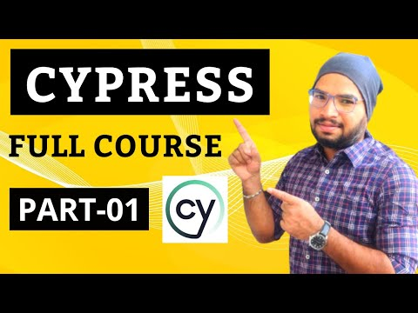
- Cypress Full Course Part-02
https://youtu.be/qa2zygrqV40?si=rOoGCCe6om2hfTaw
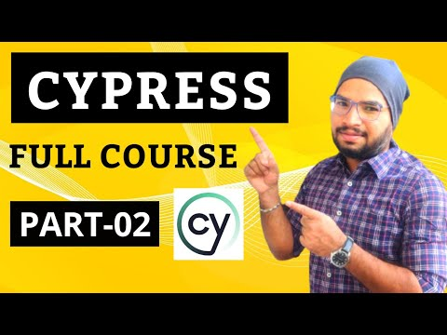

- Cypress Full Course Part-03
https://youtu.be/Df8CXzhG6Vk?si=TgEouyAjEI6Ydf-2
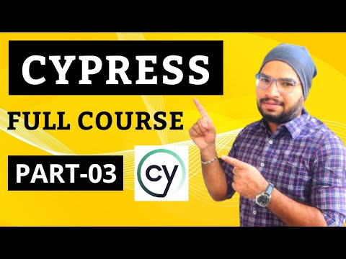
- Cypress Full Course Part-04
https://youtu.be/WaJzoZTdiW0?si=GjpJ25dIIMWmzLfM
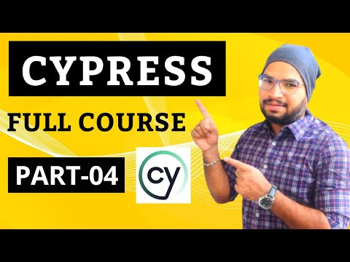

*** Learn FREELY more from Testers Talk channel ***
- Playwright with TypeScript Full Course:
https://youtube.com/playlist?list=PLUeDIlio4THEXmQxNvKmdDxAVloGTHXMr&feature=shared

- Playwright with JavaScript Full Course:
https://youtube.com/playlist?list=PLUeDIlio4THFSOUcVo_Cfam8I_IO483mV&feature=shared
- JavaScript Beginners Course:
https://youtube.com/playlist?list=PLUeDIlio4THFLrS29tJnP9yz-QKhn4mdB&feature=shared
- Cypress Full Course:
https://youtube.com/playlist?list=PLUeDIlio4THEbdE2jWyBBxkWqjk4JmHHq&feature=shared
- Postman API Testing (Manual + Automation) Full Course:
https://youtube.com/playlist?list=PLUeDIlio4THGcgNP3_Ocb_I_l4ITai5QT&feature=shared
- Rest Assured API Automation Full Course:
https://youtube.com/playlist?list=PLUeDIlio4THGL7lQXQwxsV9re_i0U2b0Q&feature=shared
- Specflow Selenium C# Full Course:
https://youtube.com/playlist?list=PLUeDIlio4THGmh41cgOGHMPxAJyK44WrA&feature=shared

- Getting Started
  - What is Cypress and Advantages, Limitations
Link: https://youtu.be/6eaWRdpd-RQ?si=qThO_t6eDN-w7phl
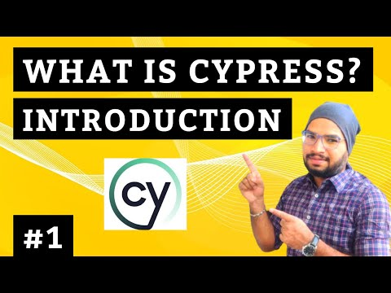

Cypress is an open source/paid automation testing tool based on JavaScript to test modern web application & API’s, Cypress is widely used by Developers and Testers. You can perform end to end testing, component testing, unit testing etc.

Cypress is completely different than Selenium WebDriver.
Cypress enables to write faster, easier & more reliable tests

Advantages:
- Easy to use
- Speed/Faster
- Cross Browser Testing
- Open Source
- Time Travel
- Debuggability
- Automatic waiting
- Screenshot & Video

Disadvantages/Limitations:
- Cypress cannot use more than one browser at the same time
- It does not provide support for multi tabs
- Cypress only supports for JavaScript programming
- Cypress does not support for Mobile App Testing and Desktop Application testing
- Cypress supported limited browser support
- XPath required external plugin

  - Cypress Vs Selenium
Link: https://youtu.be/_Uy3wHaoH-o?si=xjSXWonEZ44-1lyI
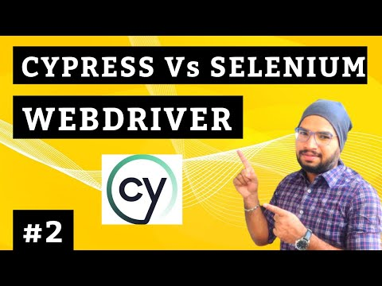

S. No | Feature | Cypress | Selenium WebDriver
1 | Programming | JavaScript only | Java, Python, C#, Ruby etc.
2 | Browser | Chrome, Edge, Firefox, Electron | Chrome, Edge, Firefox, Opera, Safari.
3 | Framework | Supports Mocha only | Junit, TestNG, Cucumber etc.
4 | Setup | Easy | Complex
5 | Documentation & Community | Rapidly growing | Used Across the glob
6 | Users | Testers or Developers | Testers only
7 | Open Source | Open Source/Paid | Open Source
8 | Mobile App Testing | No | Yes, using Appium

  - Software Requirement
Link: https://youtu.be/_iXGqe5OVxs?si=jTOpbSEflDkZB1FN
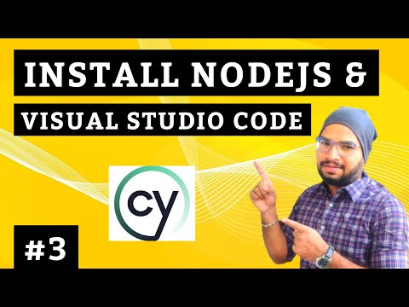

- NodeJS – Download & Install
- Visual Studio Code (VS Code) - Download & Install

  - Setup Cypress Automation Framework
Step1: npm install cypress --save-dev
Step2: npm run cypress:open
  - Scaffold Examples
  - Test Runner
Link: https://youtu.be/gRW79a1DlHQ?si=RPB4yHSqi9Q-XcJp
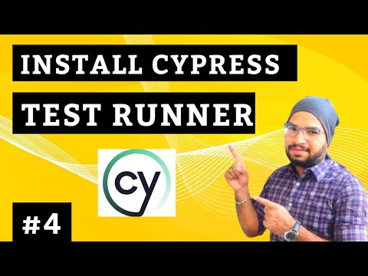

  - Default Cypress Folder Structure
Link: https://youtu.be/YFv496gHw1E?si=5Uda_8T0V3NnqLyQ


  - Cypress Studio – Record Test
Link: https://youtu.be/1aQeNbI07Jk?si=SMYyHm2Z00O0nmhF
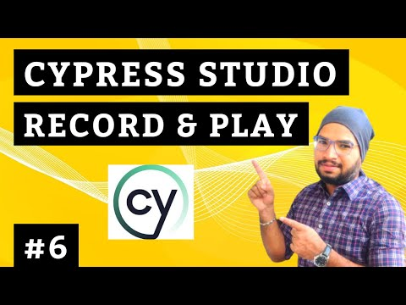

We need to specify below property in cypress.config.js file
experimentalStudio: true

  - Create First Cypress Automation Test
Link: https://youtu.be/Yn3NJfdXVOI?si=3smqPteP-v6kNQRR
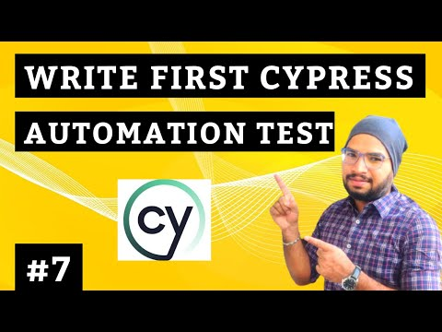

  - Logs

  - Run Cypress Test on Different Browsers
Link: https://youtu.be/ELyoLDDfBbw?si=NLfEtVKYpDWQSY-s
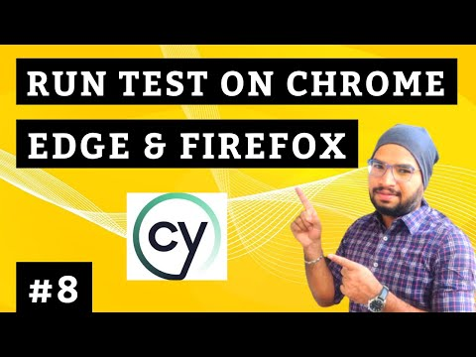

There are 2 ways to run Cypress automation test in different browsers.
- Using Cypress Test Runner
- Using Command prompt – Refer below
– npx cypress run --browser edge --headed --spec “.js path”

  - Run Cypress Test in Headless Mode
Link: https://youtu.be/U4swot55-6M?si=FPxTd6AFrFxmXEgR
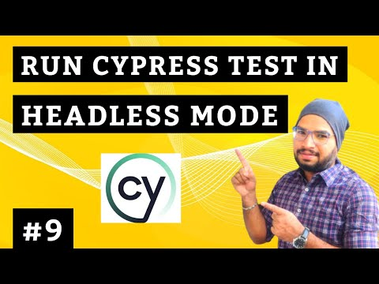

We need to use below command to run cypress test in headless mode
- npx cypress run --browser edge --spec “.js path”

  - How to Stop Auto Rerun Test in Cypress?
Link: https://youtu.be/aTXlMkiJIH8?si=Y9yBNum2z90IWP9Q
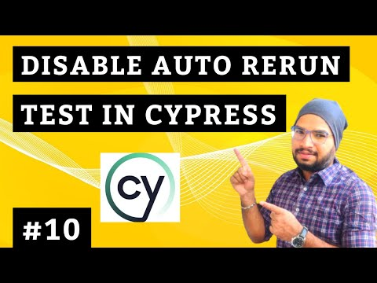

In the cypress.config.js file, we need to add below flag
watchForFileChanges:false

- Assertion, Selectors, XPath

  - Disable Fetch and XHR logs
Link: https://youtu.be/IcCzMfSojXg?si=3FX-bWuRNChDwwCs
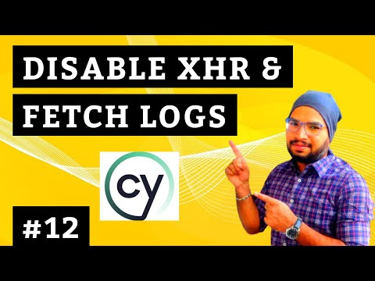

We need to add below code in support>e2e.js file.

const app = window.top;
if (!app.document.head.querySelector("[data-hide-command-log-request]")) {
const style = app.document.createElement("style");
style.innerHTML =".command-name-request, .command-name-xhr { display: none }";
style.setAttribute("data-hide-command-log-request", "");
app.document.head.appendChild(style);
}

  - IntelliSense & Intelligent Code Completion
Link: https://youtu.be/g98jIJvMV3U?si=OS3ouCvcYgORh4FU


There are 2 ways to use Intelligence code completion
- Add below line in JavaScript Spec file –
/// <reference types="Cypress" />

- Create jsconfig.json at root folder, add below code
{
"include": ["./node_modules/cypress", "cypress/**/*.js"]
}

  - Assertions
Link: https://youtu.be/-NTp4pGNSmg?si=-b0iPS82hIgScror
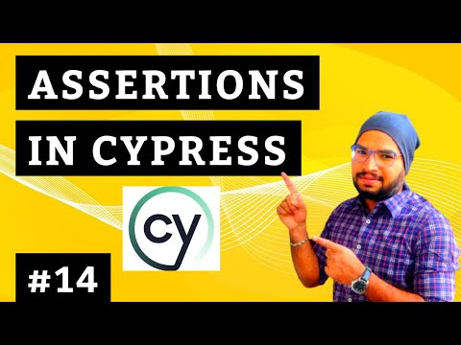

Examples:
- to.equal
cy.get('textarea[type="search"]').then((element)=>{
expect(element.text()).to.equal("javascript by testers talk");
})
- have.text
cy.get('textarea[type="search"]').should("have.text","javascript by testers talk")

- contain
cy.get('textarea[type="search"]').should("contain","javascript by testers talk")

- be.visible
cy.get('textarea[type="search"]').should("be.visible");

- have.html
cy.get('textarea[type="search"]').should("have.html","javascript by testers talk")

- have.attr
cy.get('textarea[type="search"]').should("have.html","javascript by testers talk").and("have.attr","value")

- have.attr & include
cy.get('textarea[type="search"]').should("have.html","javascript by testers talk") .and("have.attr","value").and("include","javascript by testers talk");

- to.have.length
cy.get('textarea[type="search"]').then((element)=>{
expect(element.text()).to.have.length(26);
})

  - Selectors
Link: https://youtu.be/cSa4VAHawMg?si=2DOJXGVdL8j9V_vl
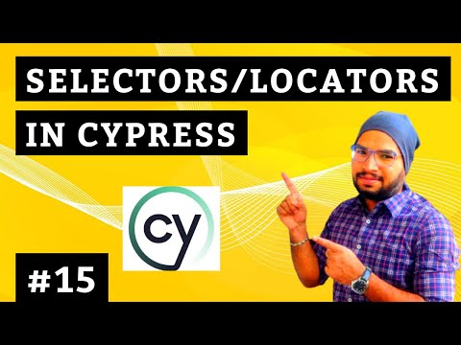

Examples:
- Attribute
cy.get('textarea[type="search"]').then((element)=>{
cy.log("Text from Google 1 : "+element.text());
})
- Id
cy.get('#APjFqb').then((element)=>{
cy.log("Text from Google 2 : "+element.text());

- Class, First, Last, Index
cy.get('.IUOThf > a').first().click();
cy.get('.IUOThf > a').last().click()
cy.get('.IUOThf > a').eq(1).click();

- Starts-with & Ends-with
cy.get('button[type^="sub"]').click();
cy.get('button[type$="mit"]').click();

- Contains – CSS Selector
cy.get('button[type*="ubmi"]').click();

- Contains – Cypress
cy.contains('Testers Talk').click();

- Tag Name
cy.get('tp-yt-paper-tab > div').eq(1).click()

  - XPath
Step1: Add install cypress-xpath plugin, using below cmd
- npm install -D cypress-xpath
Step2: Add require('cypress-xpath') line in e2e.js file
Step3: Start using xpath - cy.xpath(‘locator’)

  - Run Test from Visual Studio Code (VS Code)
Link: https://youtu.be/QS2dQCl_FyU?si=ybiCJq5VxK97UEFy
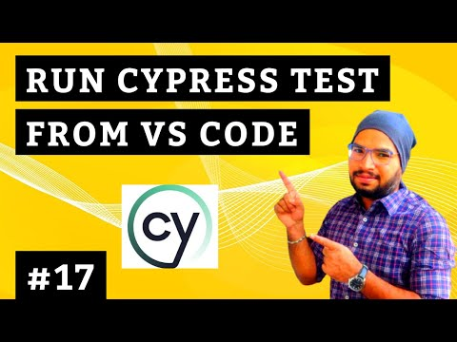

  - Dropdown List
Link: https://youtu.be/WIDmjACd3sk?si=p9mH0T5F-tTcXCGH
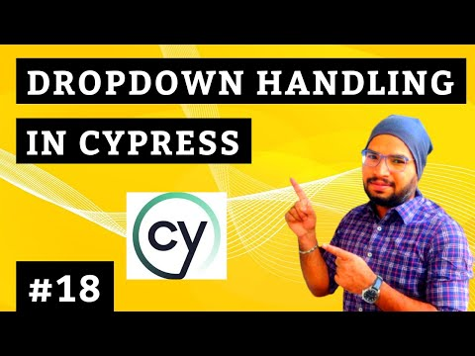

There are 3 ways to select dropdown value
- Index
- Visible Text
- Value

- How to Handle IFrames in Cypress?
Link: https://youtu.be/bXrHCTmTGsM?si=gl5B3duxbaNddt4m
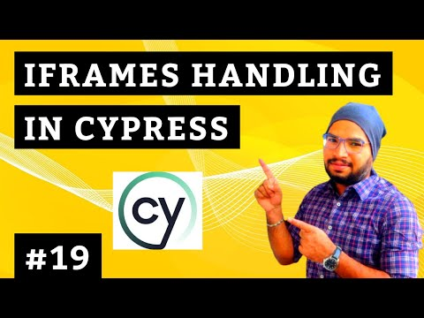

Step1: Install plugin - npm install -D cypress-iframe
Step2: Add import as import ‘cypress-iframe’
Step3: Load the frame using id or names, Perform action

- How to Scroll Up/Down in Cypress?

Link: https://youtu.be/dixZ3Q92frs?si=6FKLx7AA5OY5FkjE
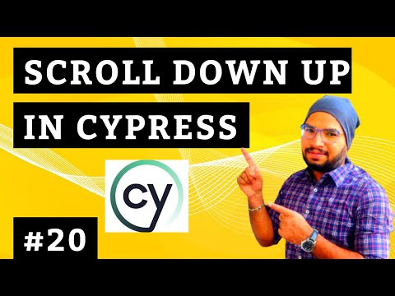
- Hooks, Retry, Repeat, Report Generation
  - Hooks
Link: https://youtu.be/uupWzXHa_GA?si=-vkE3FfcXj--_QsB
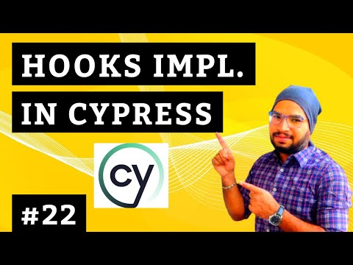

- before & after
- beforeEach & afterEach

  - Skip Test
Link: https://youtu.be/MRmXxdQ3zJA?si=3FAv9IQChiHMVn3c
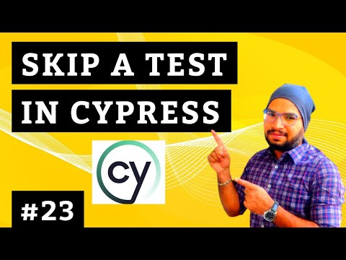

  - Repeat and Retry/ReRun
Repeat Test:
Link: https://youtu.be/jtuqTia8MgM?si=zPQdEPozAdNbVCFA
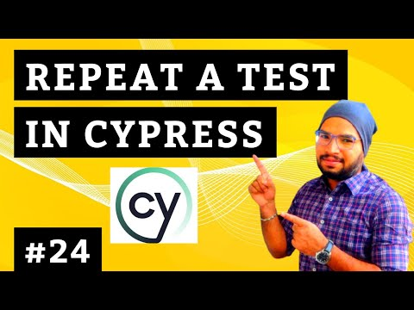
Cypress._.times(2,(k)=>{ test })

Retry/ReRun Test:
Link: https://youtu.be/KWEgtcaBPCk?si=RSTzGDbhwG8A0NlM
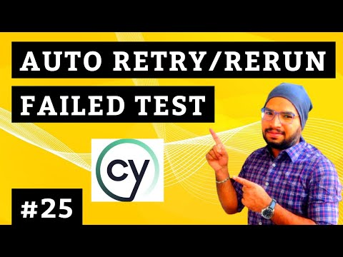

{ retries : count }

  - Report Generation
Link: https://youtu.be/F1k9GJe7W7c?si=XOyUFtIPD98RP15G
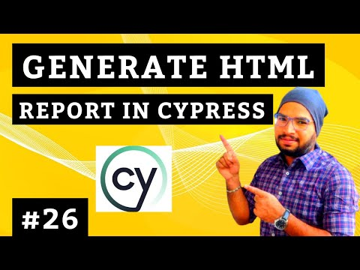

  - How to Run Multiple JavaScript Spec files
Link: https://youtu.be/QmNYZCDmPj4?si=IixYk8ZBCyF_tkTQ
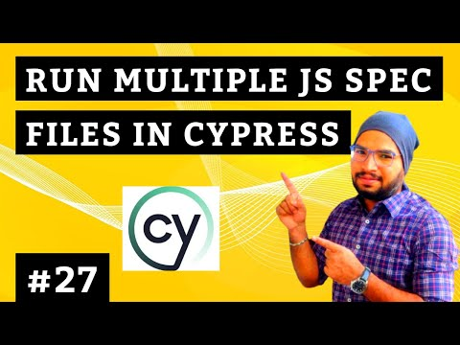
Example:
npx cypress run --browser chrome --spec "cypress\e2e\CypressSelctorsTest.cy.js,cypress\e2e\CypressXpathTest.cy.js"

  - How to Group Tests & Run Tests
Link: https://youtu.be/_NSMtRP9IoA?si=B5frVvrA30VUW8Rv
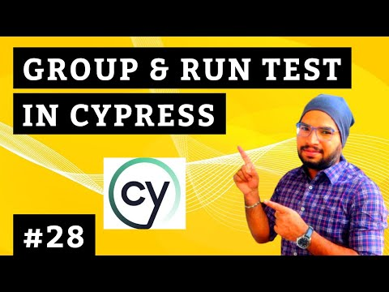
Example:
npx cypress run --browser chrome --spec "cypress\e2e\SmokeTests\*.cy.js"

4.1
Data Driven Testing using JSON File Part-01
Link: https://youtu.be/pHbKRFP33Ps?si=-Okp595JSIya473o
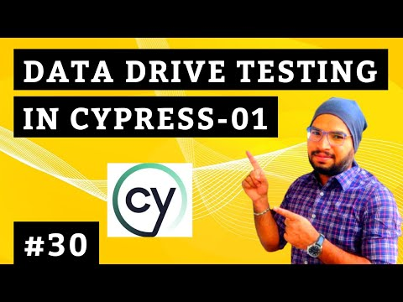
Data Driven Testing using JSON File Part-02
Link: https://youtu.be/GvdkgqcQOZ8?si=aipaYoSOMaaGVyBl
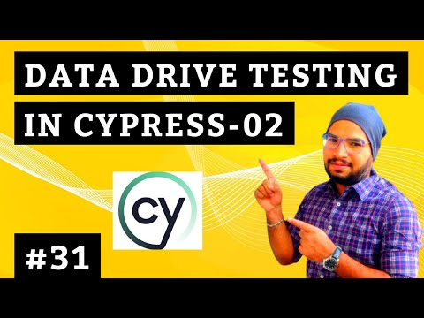
4.2 Page Object Model Design Pattern
Link: https://youtu.be/5rrkqqfwoJU?si=iTvF04ljKfAvoErq
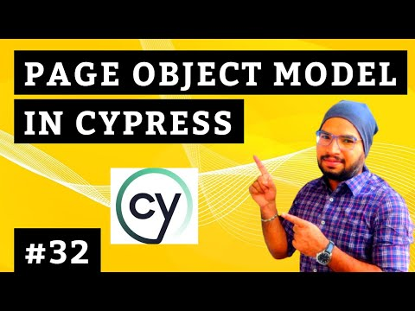

4.3 Video Recording
Link: https://youtu.be/AjUHKBVFhNs?si=86_qFRKKTvQGacnz
