- Getting Started
  - What is Java Script?
  - JavaScript Vs HTML Vs CSS
  - Node JS installation
  - Visual Studio Code installation
  - JavaScript Example with Chrome, Edge & Firefox Browsers
  - Variables & Data Types
    - Variables
      - What is Variable? Syntax & Example
      - Reserved keywords
      - Variable Mutability
    - String
      - What is String? Syntax & Example
      - Properties and Methods
    - Number
      - What is Number? Syntax & Example
    - Boolean
      - What is Boolean? Syntax & Example
- Objects and Arrays
2.1 What are Objects & its syntax and example?
2.2 Create, Access, Update & Delete Object properties
2.3 What are Arrays & its syntax and example?
2.4 Create, Access, Update & Delete elements
2.5 Comments
2.6 Readability - Prettier
2.7 Regular Expressions Basics
- Operators & Control Statements
3.1 Arithmetic Operators
3.2 Increment & Decrement
3.3 Logical Operators
3.4 Conditional Statements – if, if else, if else if
3.5 One Line if statement
3.6 Ternary Operator
3.7 Switch
3.8 typeof Operator
- Iterating with Loops, Set & Map
4.1 for loop (Sequential)
  - for loop (Enumerative)
  - while loop & do while loop
  - Set
    - What is Set? Its syntax and Example
  - Map
    - What is Map? Its syntax and Example

- Functions, Classes, Constructor
5.1 What is Function and why? With an Example
5.2 Functions with an Arguments
5.3 Variable length arguments
5.4 Object, References & Function
5.5 Classes
5.6 Constructors
5.7 Inheritance

*** Refer “JavaScript by Testers Talk” Playlist in YouTube ***
https://youtube.com/playlist?list=PLUeDIlio4THFLrS29tJnP9yz-QKhn4mdB&si=AfTpFkVb85GRgz_X

*** Subscribe to YouTube channel to get latest software testing updates ***
https://www.youtube.com/@testerstalk?sub_confirmation=1

*** Learn FREELY more from Testers Talk channel ***
- JavaScript Beginners Course:
https://youtube.com/playlist?list=PLUeDIlio4THFLrS29tJnP9yz-QKhn4mdB&feature=shared

- Playwright with JavaScript Full Course:
https://youtube.com/playlist?list=PLUeDIlio4THFSOUcVo_Cfam8I_IO483mV&feature=shared
- Playwright with TypeScript Full Course:
https://youtube.com/playlist?list=PLUeDIlio4THEXmQxNvKmdDxAVloGTHXMr&si=ghdWWTHhuuLi9Zvc
- Cypress Full Course:
https://youtube.com/playlist?list=PLUeDIlio4THEbdE2jWyBBxkWqjk4JmHHq&feature=shared
- Postman API Testing (Manual + Automation) Full Course:
https://youtube.com/playlist?list=PLUeDIlio4THGcgNP3_Ocb_I_l4ITai5QT&feature=shared
- Rest Assured API Automation Full Course:
https://youtube.com/playlist?list=PLUeDIlio4THGL7lQXQwxsV9re_i0U2b0Q&feature=shared

- Specflow Selenium C# Full Course:
https://youtube.com/playlist?list=PLUeDIlio4THGmh41cgOGHMPxAJyK44WrA&feature=shared

You can refer single video or breakdown videos
JavaScript Beginners Full Course: https://youtu.be/ACUMZ3OkExQ?si=XlviuwddIHOKXkaw
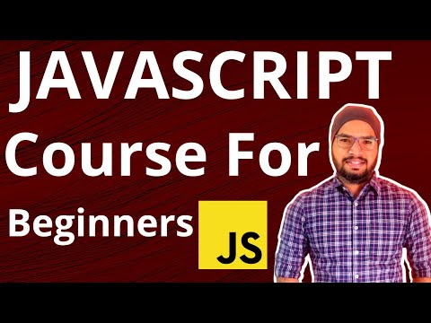
Breakdown videos
JavaScript Beginners Full Course Part-01
https://youtu.be/X46I88W6uIE?si=kiUYkl7uhiFvAu6L
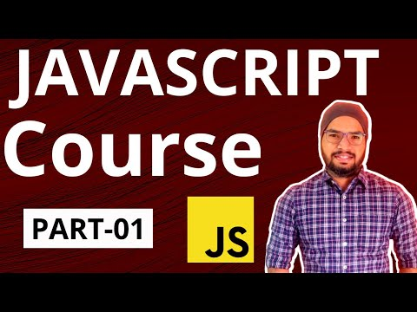

JavaScript Beginners Full Course Part-02
https://youtu.be/F53-G9XkZ0E?si=F9hkIqPj86y--4-L
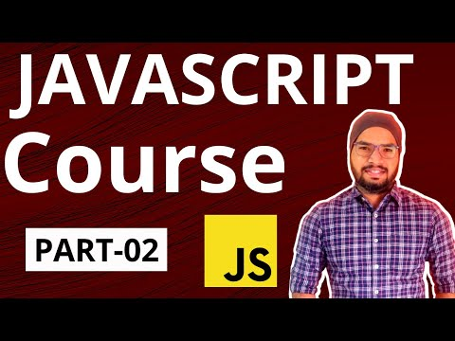

JavaScript Beginners Full Course Part-03
https://youtu.be/PneUCE97lQ8?si=FBfEVqDShN_ZLU0f
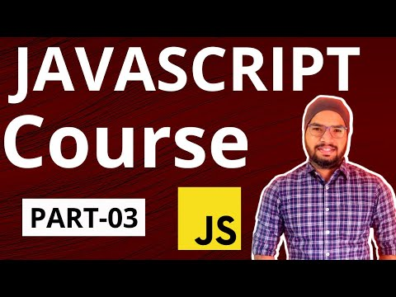

JavaScript Beginners Full Course Part-04
https://youtu.be/HgoNPWMr3mU?si=mcfE2b558Wuvcv0I
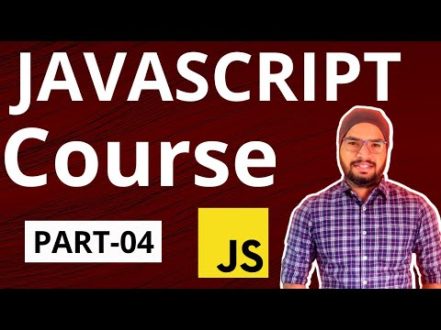

JavaScript Beginners Full Course Part-05
https://youtu.be/lWDC8VF3PtM?si=gs_hCcSQMlAZn42F
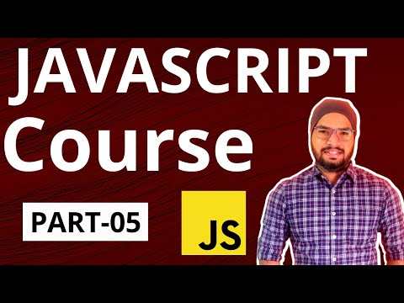

- Getting Started

  - What is JavaScript?
Link: https://youtu.be/s50YyoEH1Og?si=3iZauuf_csvtvRLQ
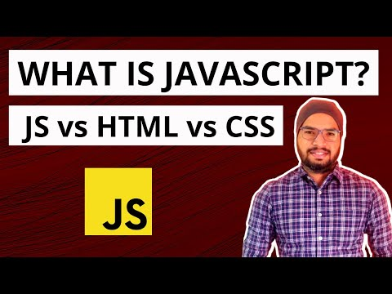

Java Script is often called JS and Java Script is one of the programming language
that is one of the core technologies of the World Wide Web, alongside HTML and CSS. As of 2023, 98.7% of websites use JavaScript on the client side for webpage behaviour.
JavaScript is also used to calculate, manipulate & validate the data. First appearance in 1995(27-year-old).

  - JavaScript Vs HTML Vs CSS
JavaScript
- Java Script also referred as JS.
- To program the behaviour of web pages
HTML
- HTML stands for Hyper Text Markup Language
- HTML is the standard markup language for Web pages
- HTML elements are the building blocks of HTML pages
- HTML elements are represented by <> tags
- To define the content of web pages
CSS
- CSS stands for Cascading Style Sheets
- CSS describes how HTML elements are to be displayed
- To specify the layout of web pages

  - Download & Installation of Node JS
Link: https://youtu.be/LEtYn8GGFac?si=ua7JsDnZOX-3c4xr
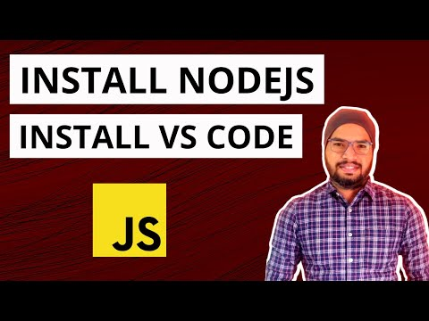

  - Download & Installation of Visual Studio Code
  - JavaScript Example with Chrome, Edge & Firefox Browsers
Link: https://youtu.be/HrNywkSuhoM?si=xp7F4fgUSCfw7nkG
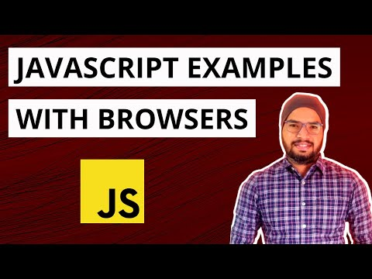

    - Variables
1.6.1.1 What is Variable? Syntax & Example
Link: https://youtu.be/-Cq9hGVmWD0?si=GyL8OqejCi2s-BPS
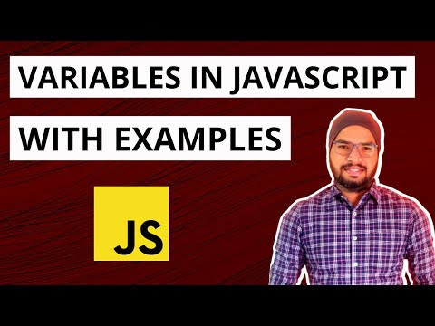

Variables are nothing but user defined names provided to containers for storing values. variables must be identified with unique names and JavaScript identifiers are case-sensitive.

Syntax: DataType variable_name=value;

Example1: var monthName = ‘August’;
Example2: var year = 2023;

The general rules creating variables (unique identifiers) are:
- Names must begin with a letter.
- Names can contain letters, digits, underscores, and dollar signs.
- Names can also begin with $ and _.
- Names are case sensitive (a and A are different variables).
- Reserved keywords (like JavaScript keywords) cannot be used as names.

      - Reserved keywords
Link: https://youtu.be/hJQoakNxBtA?si=D88Uw9OZkUic3rjE
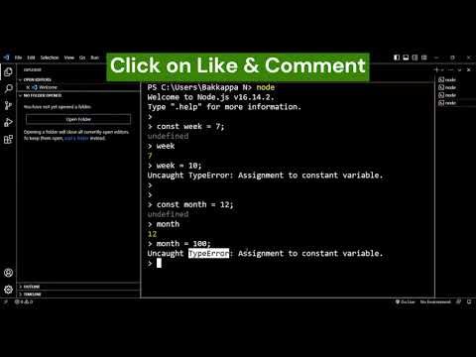

var, const, for, if, else, do while, true false etc.

      - Variable Mutability
Where variable value cannot be updated or changed.
For example, we have a week that contains 7 days only. Week value cannot be <7 or >7, similarly we have month contains 12 months only, here value cannot be <12 or >12.

Syntax: const variable_name = value;

Example1: const week = 7;
Example2: const month = 12;

    - String
      - What is String? Syntax & Example
Link: https://youtu.be/enXeI7mNC-c?si=iTqU5TlTInWFI8zd
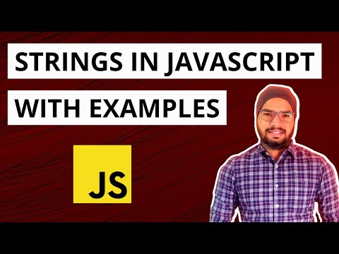

String contains group of characters and string is written in single or double quotes:

Syntax: DataType variable_name = “value” or ‘value’;

Example1: var color = “blue”; // double quotes
Example2: var color = ‘red’; // single quotes
Example3: Output: welcome to \“javascript\” tutorial;
Example4: Output: welcome \n
to \n
javascript \n
tutorial \n

      - Properties and Methods
- .length
Input: var color=’white’;
Output: 5

- .toUpperCase()
Input: var color=’white’;
Output: WHITE

- .toLowerCase()
Input: var color=’WHite’;
Output: white

- .trim()
Input: “ welcome to javascript tutorial ”;
Output: welcome to javascript tutorial

- .startsWith(‘wel’)
Input: var color=’welcome to javascript tutorial’;
Output: true

- .substring(0,2) & .substring(2)
Input: var color=’welcome to javascript tutorial’;
Output1: we
Output2: lcome to javascript tutorial

- .replace(‘o’,’x’) & .replaceAll(‘o,’x’)
Input: var color=’welcome to javascript tutorial’; //replace o with x
Output1: welcxme to javascript tutorial
Output2: welcxme tx javascript tutxrial

    - Numbers
Link: https://youtu.be/-ucoT16jU5Y?si=kWT9xxPKXcqMzWLN
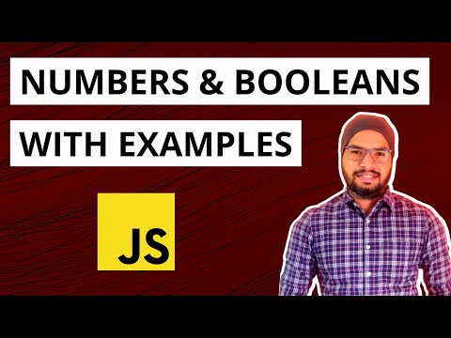

Numbers are nothing but numeric values, using numbers we can perform mathematical operations such as addition, subtraction, multiplication, division and many more.

Syntax: DataType variable_name = value;

Example1: var number1 = 10;
Example2: var number2 = -20;
Example3: var number3 = 30.123;
- Add, Sub, Mul & Div

Example4: How to add a number & string

    - Booleans
Boolean contains only true or false value. To act upon flag value

Example1: Compare numbers
Example2: Compare strings

2. Objects and Arrays
2.1 What are Objects & its syntax and example?
Link: https://youtu.be/fNPFawjDX6o?si=BTMOLx8i3y6xAmW-
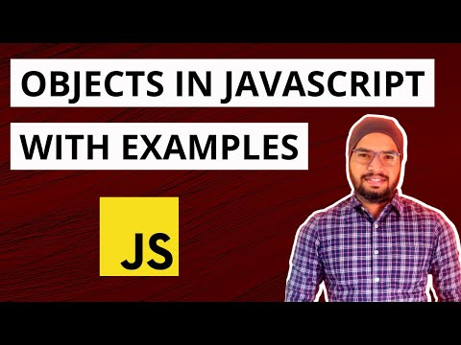

JavaScript objects are variables that contains multiple data values, The values within a JS called as properties, Object uses keys to name values. It is similar to variables.
Syntax: datatype variable_name = {key1:”value1”, key2:”value2”, key3:value3}
Example1: var car = {color : “blue”, brand : “benz”, price : 500000};

2.2 Create, Access, Update & Delete properties of an Object.
Example1: var car = {color : “blue”, brand : “benz”, price : 500000};
- Access
1st way – car.brand; – Output: benz
2nd way – car[“color”]; – Output: blue

- Update
1st way – car.brand = “audi”;
2nd way – car[“color”] = “red”;

- Delete
- delete car.color;

2.3 What are Arrays & its syntax and example?
Link: https://youtu.be/3PHzgPZa1PE?si=_IoJV_jfBZLTaF15
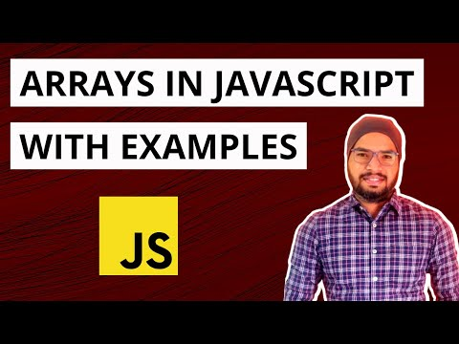

Array is a special type of variable which holds more than 1 values/elements.
Syntax: data_type variable_name = [”value1”, ”value2”, value3]
Example1: var colors = [“blue”, “white”, ”red”, 2000];

2.4 Create, Access, Update & Delete elements/values
* Access
- colors[1] – Output: white

* Update and add element
- colors[1] = “green”;
- colors.push(“orange”);

* Delete
- colors.pop();

Example2 – How to reverse array elements?

Example3 – How to merge 2 arrays?

2.5 Comments
Link: https://youtu.be/f8wR6k3YML0?si=HEBLLtcV-hacoswH
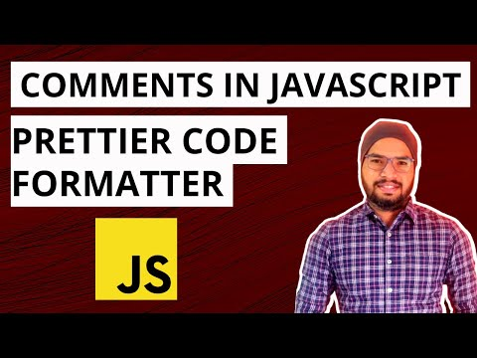

Code will be ignored withing comment section while running program.
- Single Line Comment – double forward slash (//)
- Multi Line Comment – starts with /* and ends with */

2.6 Readability – Whitespaces – Prettier

2.7 Regular Expressions Basics
Link: https://youtu.be/YE5ONLW5I28?si=Jyibn8EJOLBwd7Uc
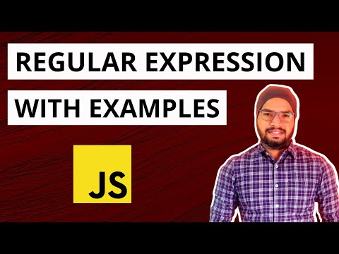

Regular expressions are patterns used to match character combinations in strings. In JavaScript, regular expressions are also objects.

Example1: var word = “welcome to javascript tutorial full course”;
var regex = /javascript/; - regular expression
regex.test(word); - return Boolean value
Example2: var regex = /JAVAscript/i;
Example3: var regex = /^tutorial/;
Example4: var regex = /course$/;

3. Operators & Control Statements
Link: https://youtu.be/A4LAtbGVoLw?si=YcYvYYDb8vxLupdN
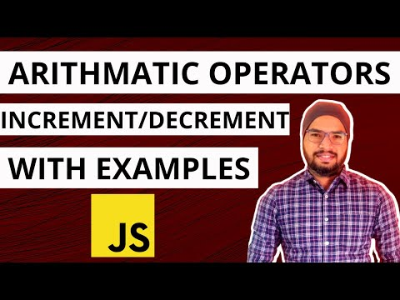

3.1 Arithmetic Operators
Arithmetic operators are used to perform mathematical operations such as addition (+), subtraction (-), multiplication (*), division (/), modulus (%), etc.

Example1: let number1 = 10, number2 = 5;
number1 + number2;
Example2: number1 - number2;
Example3: number1 * number2;
Example4: number1 / number2;
Example5: number1 % number2;
Example6: Add two string using addition operator
Example7: Comparison operator

3.2 Increment & Decrement
Link: https://youtu.be/A4LAtbGVoLw?si=YcYvYYDb8vxLupdN

Increment operator is used to increase variable value by 1.
For Example, if count=10, it increases to 11)

Decrement operator is used to decrease variable value by 1
For Example, if count=10, it decreases to 9

3.3 Logical Operators
Link: https://youtu.be/2Ns8EYziWns?si=1ReqMCCQdEo5XFkM
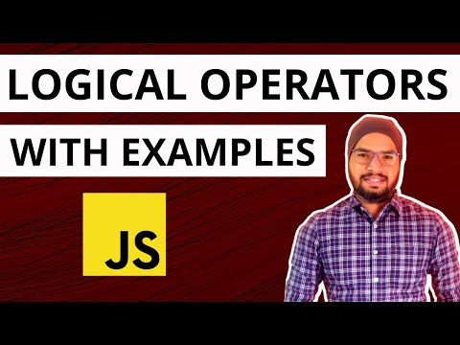

Logical operators are used to find out logic between 2 variables or 2 values.
There are 2 types of logical operators.
- OR - ||
- AND - &&
Example for OR: let color1=”red”, color2=”blue”, color3=”green”
> color1 === 'red'
Output - true
Example1: > color1 === 'red' || color2 === 'blue' //true or true
Output - true
Example2: > color1 === 'red' || color2 === 'test' //true or false
Output - true
Example3: > color1 === 'red1' || color2 === 'test' //false or false
Output – false
Example for AND:
Example1: > color1 === 'red' && color2 === 'blue'
Output - true
Example2: > color1 === 'red' && color2 === 'test'
Output - false
Example3: > color1 === 'red1' && color2 === 'test'
Output – false
Example4: > (color1 === 'red' || color2 === blue) && color3 = ‘green’
Output – true

3.4 Conditional Statements – if, if else, if else if
Link: https://youtu.be/CWYoskqH-Dw?si=R6jAVHXaXw-BFq-d
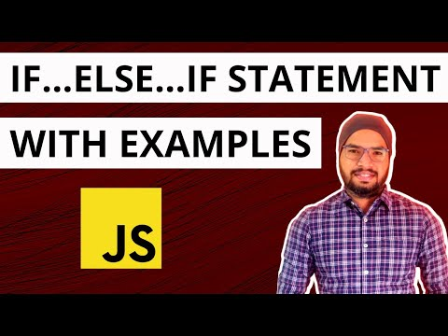

if:
Syntax: if(condition) {
//code
}

if else:
Syntax: if(condition) {
//code
} else {
//code
}

If else if:
Syntax: if(condition1) {
//code
} else if(condition2) {
//code
} else {
//code
}

3.5 One Line if statement
Link: https://youtu.be/nTUYH3ty6LQ?si=gMG3g5umPAhkfa98
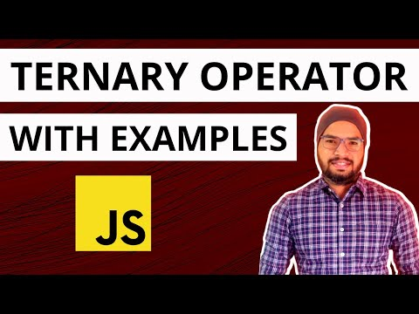

Syntax: if(condition) //code

3.6 Ternary Operator
Syntax: condition ? code1true : codefalse

3.7 Switch
Link: https://youtu.be/X-GXNSwnz4c?si=-WtjbClOmU_H4e8B
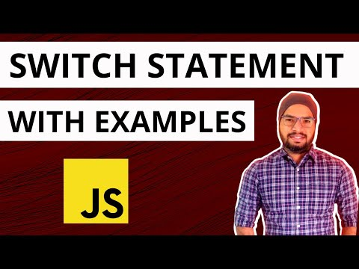

When we have multiple conditions, based on conditions you want to execute block of code?

Syntax: switch(expression/value) {
Case 1:
//code
break;
Case 2:
//code
break;
Case 3:
//code
break;
……. so, on
Default:
//code
}

3.8 typeof Operator
Link: https://youtu.be/UcQArHb0sRg?si=D3dLvUCJnkE6puK8
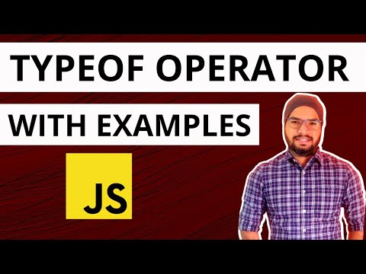

Syntax: typeof variable_name
Example1: string, number, Boolean, object
Example2: if conditions
Example3: if conditions & substring checking

- Iterating with Loops, Set & Map
  - for loop (Sequential)
Link: https://youtu.be/cCZWfW2i14U?si=lveOwBZkW4wyGL3b
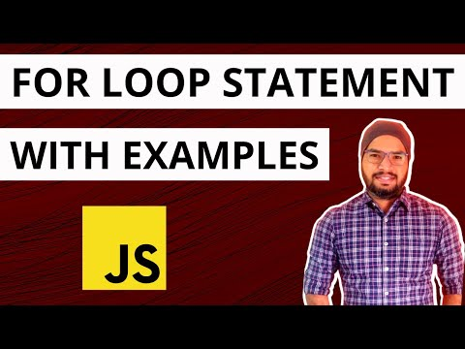

  - for loop (Enumerative)
Why for loop? When we have list of values or elements using for loop we can iterate through list of elements.

Syntax: for (initialization; condition; increment/decrement) { //code }

Example1: Basic example
Example2: New array with for loop
Example3: Iterate array with for of loop

  - while loop & do while loop
Link: https://youtu.be/lBpDXdz4sDo?si=4Kh9QB_3kmRLtVgd
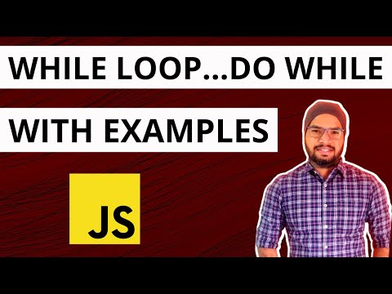

Block of code will be get executed as long as a specified condition is true.
- while loop
Syntax: while(condition) {
//code block
}
- do while loop
Syntax: do {
//code block
} while(condition)

  - Set
Link: https://youtu.be/rba_UkeoEzA?si=wmaTmW94b-SNn7t2
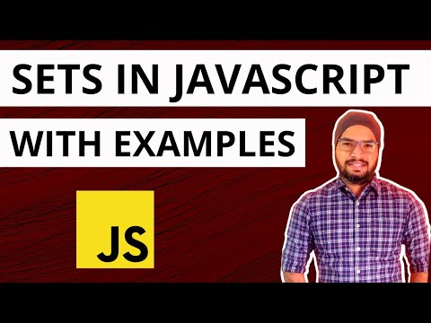

    - What is Set? Its syntax and Example
Set is nothing but an object that contains list of unique values or elements & it can store any type of value (string, Boolean, number, object).

Syntax: let variable_name = new Set ();

Examples: Create Set, Size, Verify element
Iterate set elements using for each
Iterate set elements using iterator
Delete element & Delete Set

  - Map
Link: https://youtu.be/Ww_bVmMmV08?si=e5D9knp1nWeG-QzY
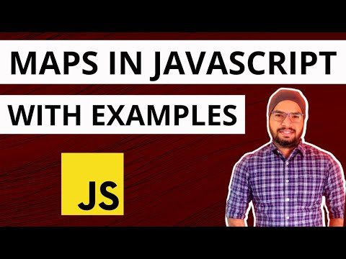

    - What is Map? Its syntax and Example
Map holds data in the form of key-value pair, where keys can be any data type such as string, number, & object etc. Map has own methods to play around map elements.

Syntax: datatype variable_name = new Map ();

Examples: Create Map, Size, Validate element
Print only keys, Print only values
Print key-value pairs using for each loop
Print key-value pairs using keys
Print key-value pairs using entries
Delete element using key

- Functions, Classes, Constructor
5.1 What is Function and why? With an Example
Link: https://youtu.be/1vgVNR-Rfbc?si=uoNmZMNPR5nEK8wc
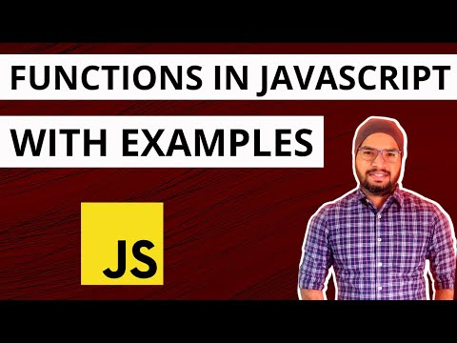

5.2 Functions with an Arguments
5.3 Variable length arguments
JavaScript function is block of code designed to perform a particular task, functions will be invoked when it is called explicitly.

Syntax1: function function_name () {
// code block
}
Syntax2: function function_name (arg1, agr2, arg3…. n) {
// code block
}

Examples:
- Basic function
- Function with arguments
- Function with optional arguments
- Function with variable length arguments

5.4 Object, References & Function
Link: https://youtu.be/LqaM6R6y7v8?si=pprFKaL_aSuttQII
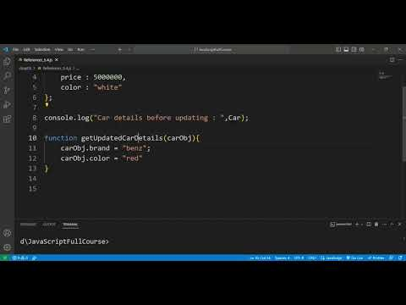

5.5 Classes
Link: https://youtu.be/_gVQQqrvJn4?si=ImXlXQesy5ZEci3X
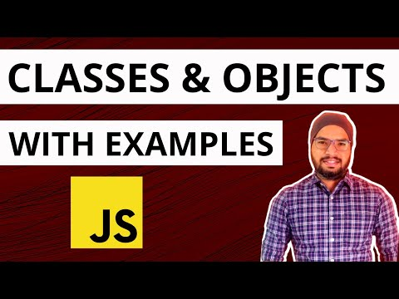

Class is a template for JavaScript objects, it contains constructors and functions.
Class is not an object, class can be created by using “class” keyword.

Syntax1: class class_name {
//constructors
// functions or methods
}

Syntax2: var object_name = new class_name ();

5.6 Constructor
Link: https://youtu.be/ix61UCO2YxU?si=ikHHlFS9rZX0xgZQ
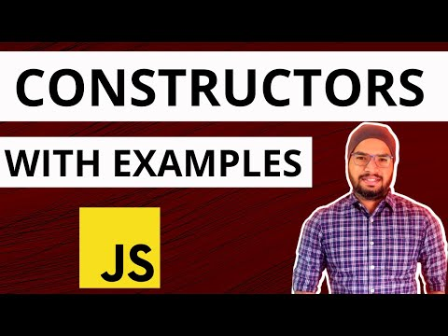

Constructor is a special method of a class for creating and initializing an object
instance of that class, Constructors will be invoked when class object is created.
Class cannot have more than 1 constructor.

Syntax: class class_name {
constructor () {
// code block
}
//functions or methods
}

5.7 Inheritance
Link: https://youtu.be/ix61UCO2YxU?si=XpcU61LSCoK7N7_c

Inheritance is concept of inheriting properties of base class to sub class or parent
class to child class by using “extends” keyword

Syntax: class Parent {
//code block
}

class Child extends Parent {
//code block
}

