- Getting Started with Playwright
  - What is Playwright and Advantages, Limitations
  - Playwright Architecture
  - Playwright Vs Cypress
  - Playwright Vs Selenium WebDriver
  - Software Requirement
  - Install Nodejs & VS Code
  - Install Playwright in VS Code
  - Folder Structure
  - Test Explorer
  - Run Test
  - Run Test on Google Chrome & Microsoft Edge Browsers
  - Record Test in VS Code
  - Generate HTML Test Report
  - Record at Cursor
  - Commonly used Terminologies
  - First Playwright Automation Test
  - Pick Locator in VS Code
  - Install Playwright from Command Prompt
  - Run Test in Headless mode
  - Run Test in UI mode
  - Run Specific Spec File
  - Run Test on Different Browsers
  - Codegen – Record and Play Test

- Locators, Assertions, Hooks, Annotations & Actions
  - Locators
  - Screenshots
  - Hooks
  - Add Screenshots to HTML Report when Test failed
  - Dropdown List, IFrames & Date Picker
  - Mouse Clicks, Keyboard Actions, Drag & Drop
  - Assertions - Hard & Soft Assertions
  - Watch mode
  - Test Traces, Actions metadata, Console, Log, Network

- Retry, Repeat, Visual Testing & Parallelism
  - Annotations – Skip Test, Only
  - Grouping Tests
  - Tag Test
  - Repeat
  - Retry
  - Parallelism/Parallel Test Execution
  - Parametrize Tests
  - Visual Comparison - Visual Testing

- Page Object Model, Video, Environments, Data Driven Testing
  - Env File
  - Data Driven Testing
  - Run Tests on Multiple Environments – QA, STAGE, PROD etc.
  - Page Object Model
  - Video Recording
  - Full Screen Browser

- Playwright - API Testing
  - Post API Request using static API request body
  - Post API Request using static JSON file
  - Post API Request using dynamic API request body
  - Post API Request using dynamic JSON file
  - GET API Request
  - Query Parameter
  - PUT API Request
  - PATCH API Request
  - DELETE API Request
  - Allure Report with Playwright

- Azure DevOps Pipeline
  - Repository Creation
  - Push Repository to Azure DeveOps
  - Create Pipeline
  - Run Pipeline
  - Pulish Results in ADO

- Rerun Failed Tests, Browser Context, Popup’s, Alerts etc.
  - Browser Context – Open multiple browser sessions
  - Run Test in already Opened Browser
  - Rerun All Failed Tests at 1 Shot
  - Tags
  - Popups/Alerts/Dialogues
  - Playwright Multiple Test Reports
  - Upload File
  - Download File

*** Refer “Playwright by Testers Talk” Playlist in YouTube ***
https://youtube.com/playlist?list=PLUeDIlio4THFSOUcVo_Cfam8I_IO483mV&feature=shared

*** Subscribe to YouTube channel to get latest software testing updates ***
https://www.youtube.com/@testerstalk?sub_confirmation=1

*** Learn FREELY more from Testers Talk channel ***
- Playwright with JavaScript Full Course:
https://youtube.com/playlist?list=PLUeDIlio4THFSOUcVo_Cfam8I_IO483mV&feature=shared
- Playwright with TypeScript Full Course:
https://youtube.com/playlist?list=PLUeDIlio4THEXmQxNvKmdDxAVloGTHXMr&si=ghdWWTHhuuLi9Zvc
- JavaScript Beginners Course:
https://youtube.com/playlist?list=PLUeDIlio4THFLrS29tJnP9yz-QKhn4mdB&feature=shared
- Cypress Full Course:
https://youtube.com/playlist?list=PLUeDIlio4THEbdE2jWyBBxkWqjk4JmHHq&feature=shared
- Postman API Testing (Manual + Automation) Full Course:
https://youtube.com/playlist?list=PLUeDIlio4THGcgNP3_Ocb_I_l4ITai5QT&feature=shared
- Rest Assured API Automation Full Course:
https://youtube.com/playlist?list=PLUeDIlio4THGL7lQXQwxsV9re_i0U2b0Q&feature=shared

- Specflow Selenium C# Full Course:
https://youtube.com/playlist?list=PLUeDIlio4THGmh41cgOGHMPxAJyK44WrA&feature=shared

- Playwright with JavaScript UI Automation - Part01
Link: https://youtu.be/2poXBtifpzA?si=ND9kiDoj6mcJ-oK3
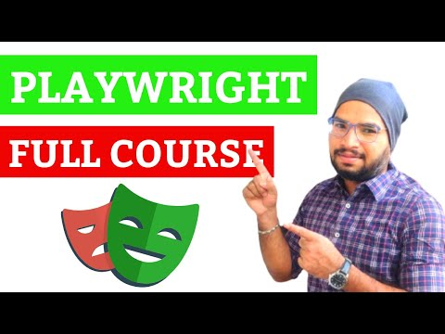
- Playwright with JavaScript API Automation - Part02
Link: https://youtu.be/lM-lqPun9P8?si=MzSzU8HhdF9EeLak
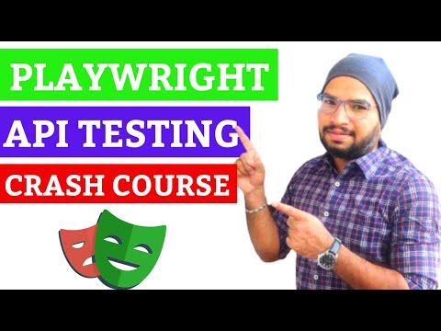
- Playwright with JavaScript CICD – Azure DevOps Pipeline - Part03
Link: https://youtu.be/Exx2M5Pz06g?si=vOvWc-XsvShCyYnE
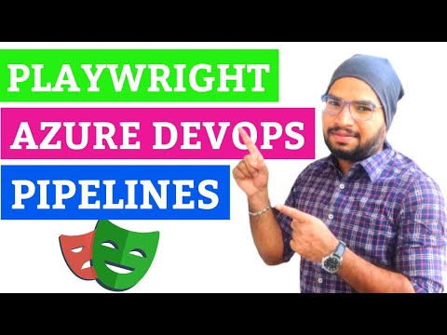

- Playwright with JavaScript - CRM Project - Part04
Link: https://youtu.be/WwovRRp0f4o?si=RKyVoswYmm9qql82
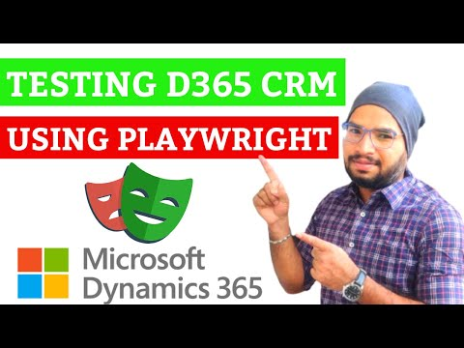

*** Topic wise breakdown tutorials ***
- Getting Started with Playwright
1.1 What is Playwright and Advantages, Limitations
Link: https://youtu.be/dMiDYASMlX8?si=GsP1-y5a2MNoTqip
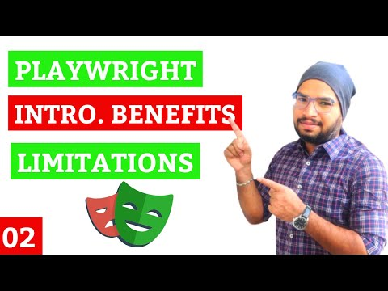
Playwright is an open-source automation testing tool which is used test end to end modern web mobile applications in headed or headless mode.
Advantages:
- Cross Browser Testing - Chrome, Edge, Chromium, Firefox & Webkit.
- Cross Platform Testing - Windows, Linux & MacOS.
- Cross Programming Language - JavaScript, TS, Python, .NET & Java.
- Mobile/Web - Mobile emulation of Google Chrome for Android and Mobile Safari.
- Auto Wait
- Tracing
- Reporting
- Dynamic Wait Assertions
- Faster & Reliable
- Powerful Tooling – Codegen, Playwright Inspector & Trace Viewer
- No flaky test

Disadvantages/Limitations:
- Playwright does not have a big community compared to selenium webdriver.
- It does not work on legacy browsers such IE11.
- It is not possible to test with real device mobile apps.

1.2 Playwright Architecture
Link: https://youtu.be/f4y1pJdkdNA?si=pDvdV5-mqmO7A_r3
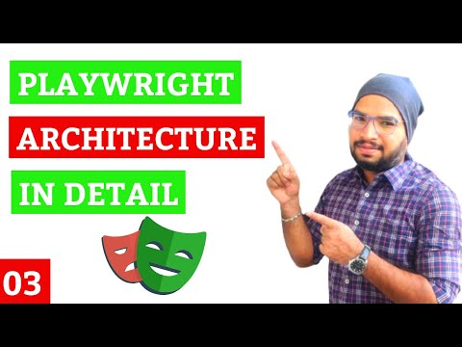

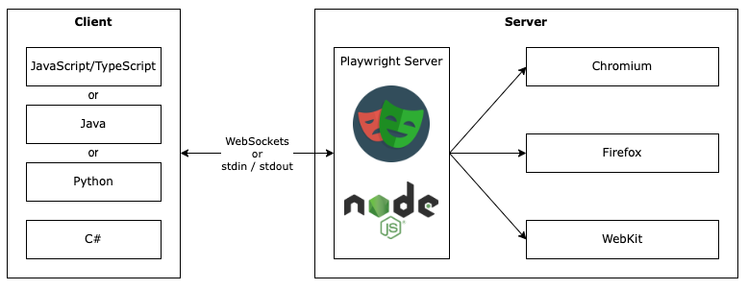
- Client: In the client side our automation test code will be written in different languages such as javascript, python, c# .net etc.
- Server: The server communicates between client and web browser engines such as chrome, firefox, edge etc.
Playwright uses CDP to communicate with chromium or chrome browser, similarly playwright has implemented CDP to communicate with other browser such as firefox webkit etc.
- WebSocket Protocol: WebSocket connection is established to the server from client by using process called Web Socket Handshake, WebSocket sends response as soon as it gets request in real time. Connection will be not terminated until unless connection is closed by either client or server.
- CDP (Chrome DevTools Protocol):
- Client & Server Communication: When test is triggered Client converts automation test into JSON format and sends to server over WebSocket Protocol
- Playwright communicates all the request over single websocket protocol connection.
- Test failure & test flakiness is less as because executing all the tests over single websocket connection.

  - Playwright Vs Cypress
Link: https://youtu.be/nRzk4Zj_Bps?si=pSW2uWV2BxzJdpDT
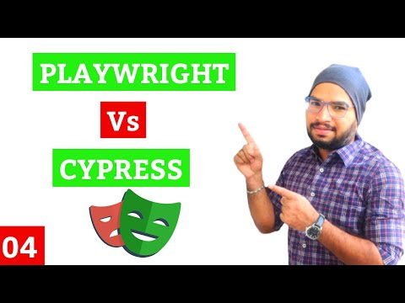

S. No | Feature | Playwright | Cypress
1 | Programming | JavaScript, TS, Java, Python & C# .NET | Supports JavaScript only
2 | Browser Support | Chrome, Edge, Firefox, Webkit, Chromium, Mobile Chrome & Safari | Chrome, Edge, Firefox, Electron
3 | Framework | Supports for Mocha, Jest & Jasmine | Supports Mocha only
4 | OS | Windows, Linux, and macOS | Windows, Linux, and macOS 10.9 and above
5 | Open Source | Yes | Not completely open source
6 | Support | Playwright is a new tool so playwright community support is bit less | Strong community support from professionals across the world
7 | Mobile App Testing | Support for viewport & mobile emulator/real devices | Supports for viewport
8 | Reporting | Yes | No
9 | Record | Codegen | Cypress Studio

  - Playwright Vs Selenium WebDriver
Link: https://youtu.be/p1CIYTyKOlc?si=fAHw0gVLtx5nEIRe
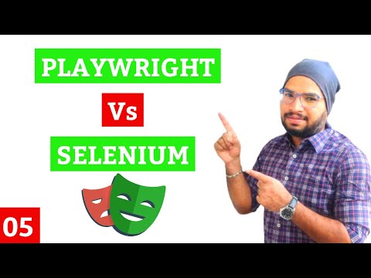

S. No | Feature | Playwright | Selenium WebDriver
1 | Programming | JavaScript, TS, Java, Python & C# .NET | JavaScript, TS, Java, Python, C# .NET, Ruby, Perl & PHP
2 | Browser Support | Chrome, Edge, Firefox, Chromium, Mobile Chrome, Safari & Webkit | Chrome, Edge, Firefox, Safari & Opera
3 | Framework | Jest/Jasmine, AVA, Mocha, and Vitest | Jest/Jasmine, Mocha, WebDriver IO, Protractor, TestNG, JUnit, and NUnit
4 | OS Supported | Windows, Linux, and macOS | Windows, Mac OS, Linux, and Solaris
5 | Open Source | Yes – by Microsoft | Yes - Community
6 | Support | As playwright is new so playwright community is growing rapidly | Large community support & documentation
7 | Mobile App Testing | Yes | No
8 | Speed | Fast | Slow
9 | Reporting | Yes | No
10 | Auto Wait | Yes | No
11 | Architecture | Headless browser with event-driven architecture | 4-layer architecture (Selenium Client Library, JSON Wire Protocol, Browser Drivers and Browsers)
12 | Prerequisite | Nodejs | API & drivers are required
13 | Video Recording | Yes | No

  - Software Requirement
Link: https://youtu.be/Ohn9V-cr5Rw?si=OAXJrFRlCojEZUJe
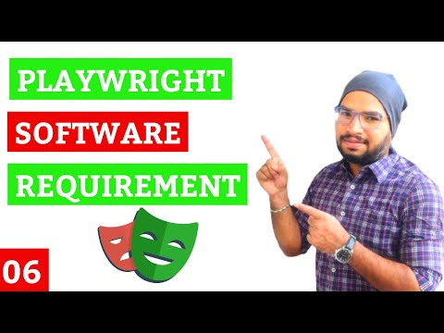

- NodeJS
- Visual Studio Code (VS Code)
- JavaScript
- Operating System - Window/MAC/Linux

  - Install Nodejs & VS Code
Link: https://youtu.be/nGL_aRZxpOo?si=a4sC-GKm04oLhQte
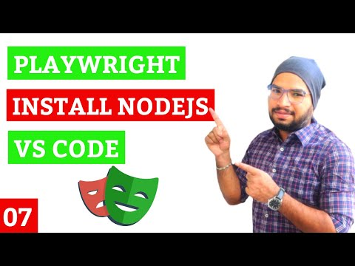

- NodeJS – Download & Install
- Visual Studio Code (VS Code) - Download & Install

  - Install Playwright in VS Code
Link: https://youtu.be/RgS63OwJiPE?si=lQhRaKlQwuoImbIz
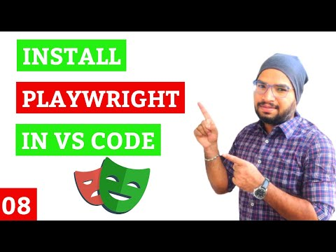

Step1: We need to install “Playwright Test for VSCode” extension.
Step2: Press Ctrl+Shift+P, enter “install playwright”
Step3: Select Playwright configurations & click on “OK”
Then wait for some time to complete the installation.

  - Folder Structure
Link: https://youtu.be/wC_JVXy6EK0?si=sCDySmmXOorbDHsX
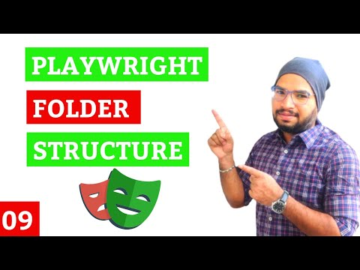

  - Run Test
  - Test Explorer
Link: https://youtu.be/w9T50WOaHe8?si=vWeZQLQ8UJb6eiIQ
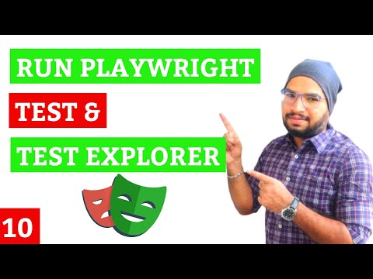

  - Run Test on Google Chrome & Microsoft Edge Browsers
Link: https://youtu.be/aI0KqyTGogI?si=ShLgyFROvnpzk-h5
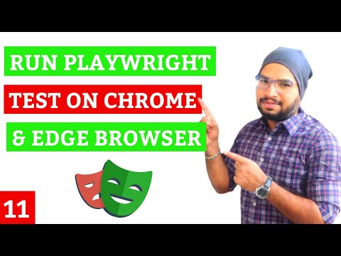

  - Record Test in Visual Studio Code
  - Generate HTML Test Report
Link: https://youtu.be/QqkNNyN0Sqk?si=stZBJBHRh3Rxv0Pe
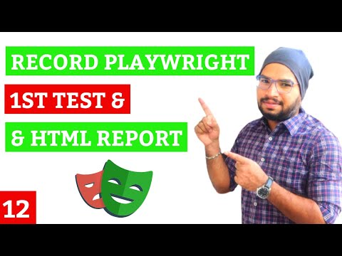

  - Record at Cursor
Link: https://youtu.be/o5AitDULEWk?si=ZiSiSkkx5tHiX7Sv
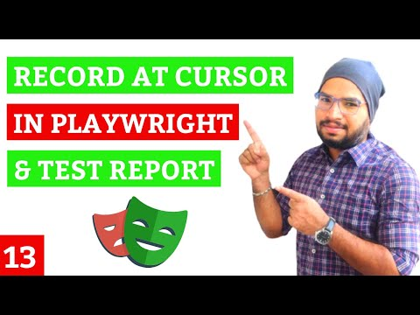
  - Commonly used Terminologies in Playwright Test
Link: https://youtu.be/Z6qsZsz73fU?si=uNpwETem3qkUl7E7
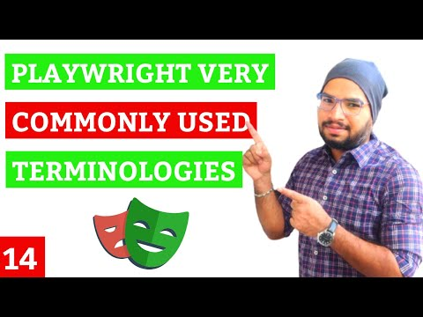
- require? - To include playwright module or to use playwright module in current JavaScript file
- async & await? - async is a function, await is valid inside async function only.
- Zero or more await expressions can be written inside async function
- When each time async functions is called, it returns a new promise value. Which will be resolved with the value returned by the async function or rejected with an exception.
- page? – It is a browser context object, using context we can open URL & interact with browser.
- expect? –for It is a library JavaScript & TypeScript intended for use with test runner such as Jest or Playwright Test.
- It lets you write better assertions for end-to-end testing or component testing.

  - First Playwright Automation Test
  - Pick Locator in Playwright
Link: https://youtu.be/khtHycQJ5Ug?si=QQEtD9IhNAjSsHSr
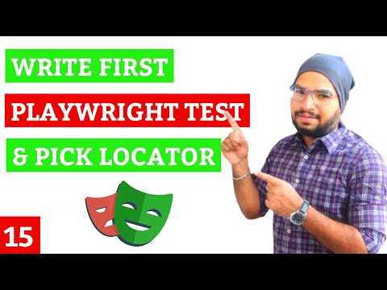

  - Install Playwright using Command Prompt
Link: https://youtu.be/cu6DHrLI_1c?si=wpUarduOa-s4uziY
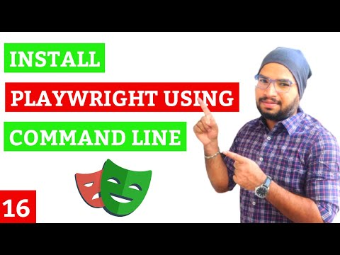
Step1: Enter ‘npm init playwright@latest’
Step2: Select Playwright configurations.
Then wait for some time to install Playwright…

  - Run Test in Headless mode
- Playwright Test Report
Link: https://youtu.be/plUOGycfsGs?si=YEnH10ZwooXYnIeC
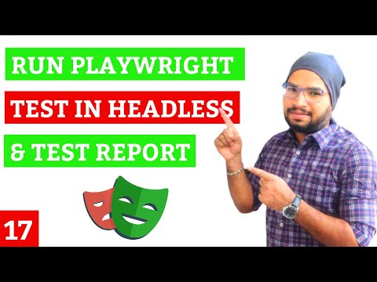
  - Run Test in Headed Mode
Link: https://youtu.be/4NgnFqdEn_I?si=9_lQUIzLE9percim
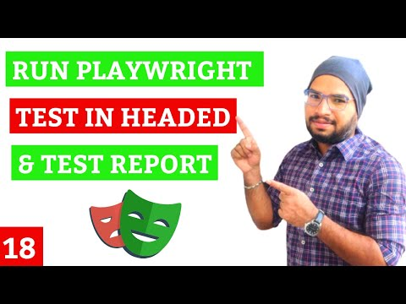

  - Run Specific Playwright Spec File
Link: https://youtu.be/3YK035c80b0?si=2_o_S2kED0dsiXIX
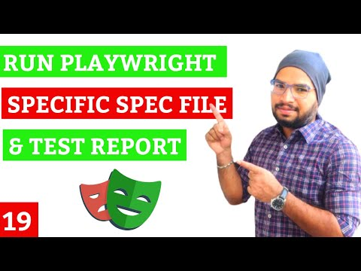

  - Run Test on Different Browsers
Link: https://youtu.be/ZvmPChmuTEc?si=b9-LO3SQz25ag3MK
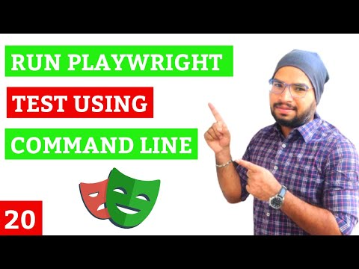

  - Record Test using Codegen
Link: https://youtu.be/8LhEGsirbNM?si=-ZrUmcEYzHeaLutj
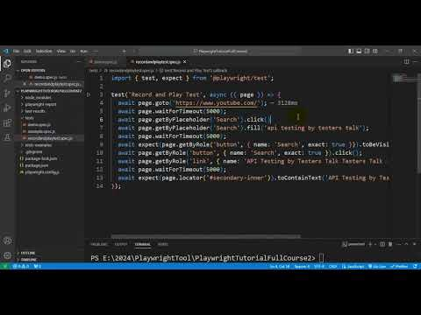

- Locators, Assertions, Hooks, Annotations & Actions
2.1 Locators - Identify Web Element
Link: https://youtu.be/05joHjdCJ2I?si=v7D4aCHFJujYYK4N
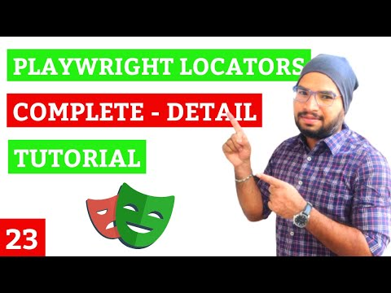
- By Role
Example - await page.getByRole(‘link’,{name: ‘value’}).click();

- By Label
Example - await page.getByLabel(‘value’,
{exact : true}).fill(‘value’);

- By Alt Text
Example - await page.getByAltText(‘text’).click();

- By Test Id
Example - await page.getByTestId(‘value).fill(‘testers talk’);

- By Text
Example - await page.getByText(‘any text’).click(); //partial

//complete text should be present
Example - await page.getByText(‘any text’, {exact :true}).click();

- By Title
Example - await page.getByTitle(‘cypress by testers talk).click();

- XPath
Example - await page.locator (“xpath=//*[@attr=’value’]”).click();

- CSS Selector
Example - await page.locator (“css=//*[@attr=’value’]”).click();

- By Placeholder
Example - await page.ByPlaceholder (‘value]).click();

2.2 Screenshots
Link: https://youtu.be/XmIkVR_tkUI?si=hi3akQycnX2yawgC
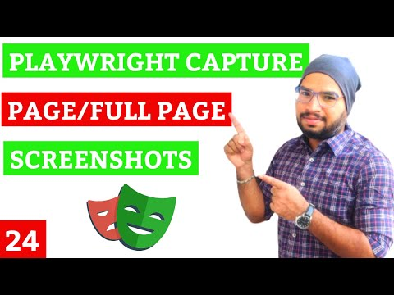

i) Element screenshot
ii) Page screenshot
iii) Full Page screenshot

2.3 Hooks
Link: https://youtu.be/pKXvi-Ssl8k?si=9HPfTR3h8NJCj0JY
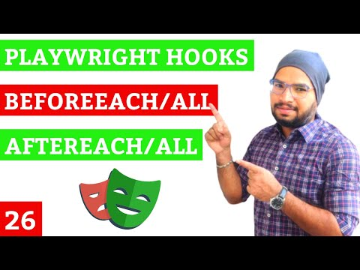
i) beforeEach()
ii) beforeAll()
iii) afterEach()
iv) afterAll()

2.4 Add Screenshots to Playwright Test Report when Test failed
Link: https://youtu.be/u3umvYYjkuM?si=lNaNfK0xDPcc7a7g
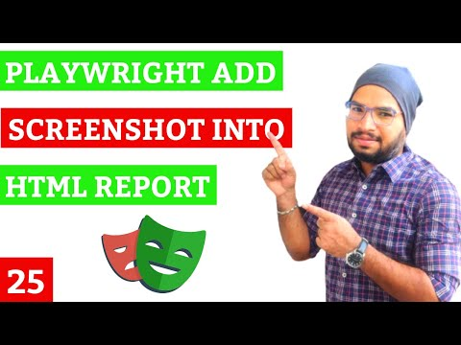

2.5 Dropdown List, IFrames & Drag & Drop
Dropdown List:
Link: https://youtu.be/eYwVRPJAveg?si=S5CCnxjRKdt_DjzM
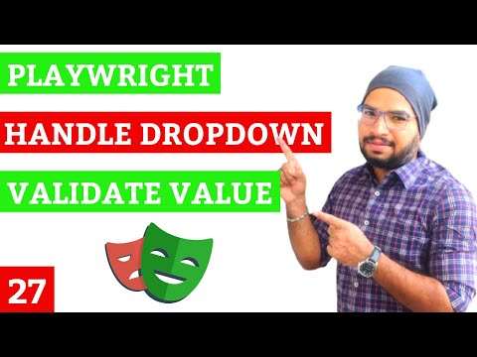

- Value
- Visible Text

IFrame, Drag and Drop
Link: https://youtu.be/HSZIn1jfU08?si=oCagBVxnc5zRgVCr
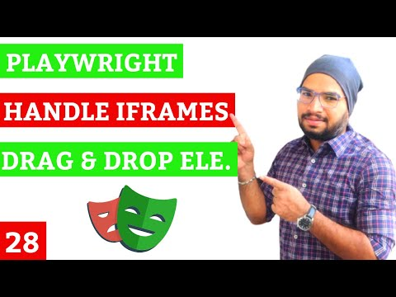

2.6 Mouse Actions, Keyboard Actions & Date Picker
Mouse Actions
Link: https://youtu.be/RszZ4dxOFoc?si=9SNgGsjzzONy6b2L
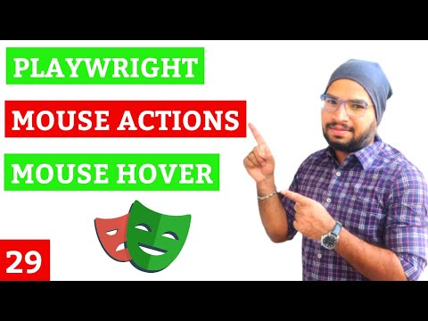

Keyboard Actions
Link: https://youtu.be/rwyk78OwZDs?si=J3vN9mVfOTnIrBYu
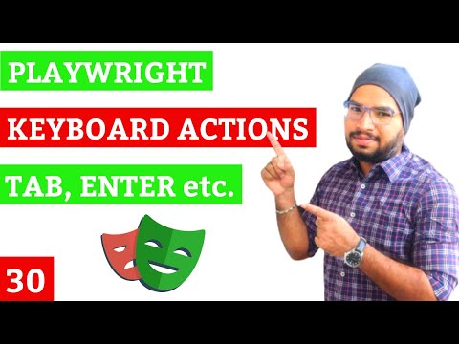

Date Picker
Link: https://youtu.be/CgXC7mFpv-0?si=u243O-kMcaT9daGg
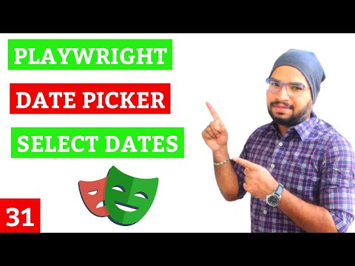

2.7 Assertions – Hard Assertion & Soft Assertions
Link: https://youtu.be/VYCvMGHVHoM?si=bPYpBsLHqKsJrb93
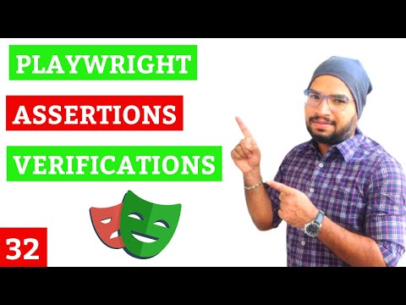
i) URL - toHaveURL ()
ii) title - toHaveTitle ()
iii) text - toHaveText ()
iv) Editable - toBeEditable()
v) Visible - toBeVisible ()
vi) Enabled - toBeEnabled ()
vii) Disabled - toBeDisabled ()
viii) Empty - toBeEmpty ()
ix) Count - toHaveCount ()

Soft Assertion
Link: https://youtu.be/Sgb_m9IQ2nw?si=wTf4xqXrA4J1Toun


2.8 Watch mode
Link: https://youtu.be/qJYk5uCTQAI?si=9aEUWxQr9TqTICUm
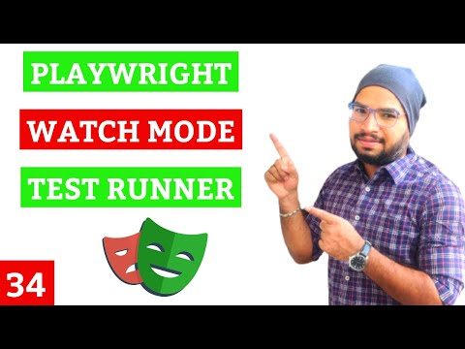

  - Test Traces, Actions, Metadata, Console, Log, Network
Link: https://youtu.be/rvXzSuy3JGk?si=O3r5rTJbdDnRQOVi
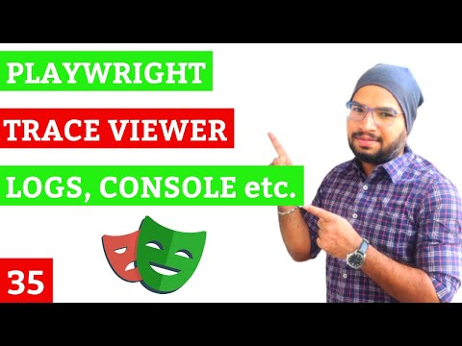

- Retry, Repeat, Visual Testing & Parallelism
3.1 Annotations – Skip Test, Only
Link: https://youtu.be/vtxHBcZnDAA?si=0NbW4rEzwOt9v7zB
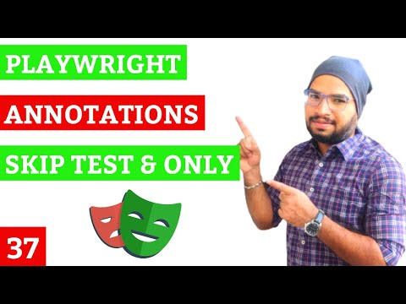

3.2 Grouping Tests
Link: https://youtu.be/VRLzfS1NLLk?si=k9jPwzC5r52OpbsO
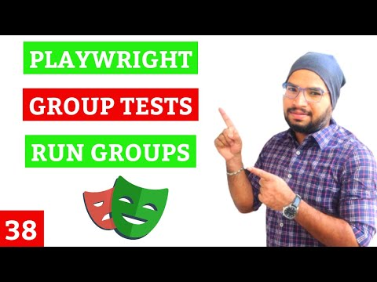

3.3 Tag Test
Link: https://youtu.be/bRaRQR9PPp4?si=0cUgymqOW34p_sjO
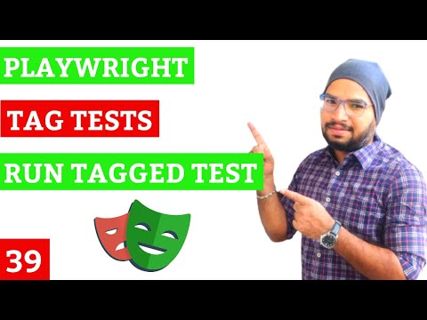
3.4 Repeat
Link: https://youtu.be/RgUzDgnTfCA?si=w9-SpKlaBbevUsNZ
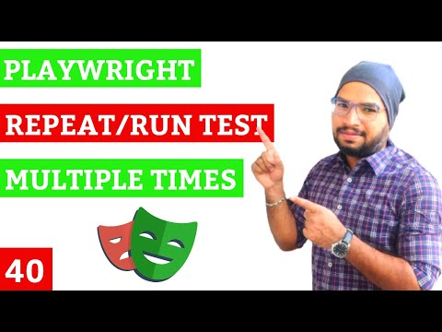

  - Retry
Link: https://youtu.be/r3TCpZs9Cn8?si=6-9R0x8m4Gp73HxG
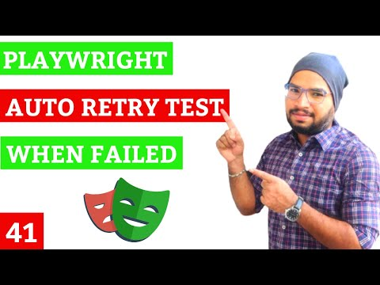
  - Parallelism/Parallel Test Execution
Link: https://youtu.be/3BDHAnTFa9A?si=h8zK0_dWpkuScka7
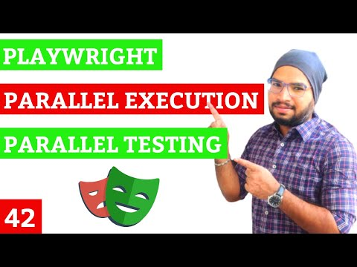

  - Parametrize Tests
Link: https://youtu.be/gkx0Zq-S9vs?si=e7vH5esmsy24pu_e
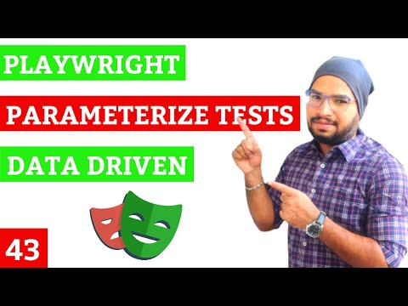

  - Visual Comparison - Visual Testing
Link: https://youtu.be/ELUyoQKAXpE?si=Hfgj6IMuMEpWUwHE
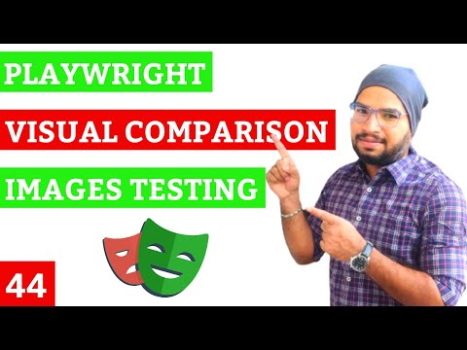

- Page Object Model, Video, Environments, Data Driven Testing

4.1 Env File
Link: https://youtu.be/Zq11KhZd8jU?si=-8cbJHB0dLW4IziC
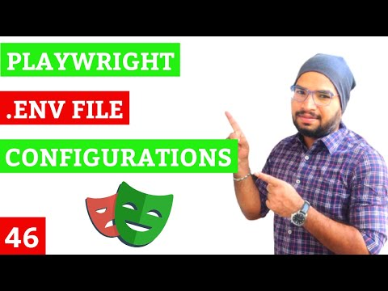

4.2 Data Driven Testing
4.2.1 Data Driven Testing Using JSON File
Link: https://youtu.be/pCiWGYzJfSY?si=V-bJbZPXhAe5rpAd
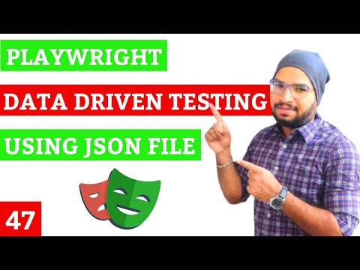

4.2.2 Data Driven Testing Using CSV File
Link: https://youtu.be/AHaAO7AY_Nw?si=luOixQQKAZGurlWA
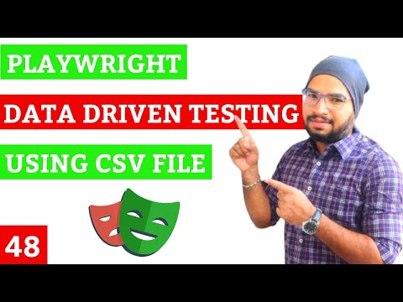

4.3 Run Tests on Multiple Environments
– QA, STAGE & PROD
Link: https://youtu.be/vi0xxnaVeos?si=38Vl8hurinXSgSsV
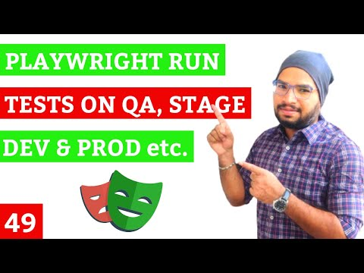

4.4 Implement Page Object Model in Playwright
Link: https://youtu.be/T1-BxVD34bE?si=ykYffxVF09wLKJQf
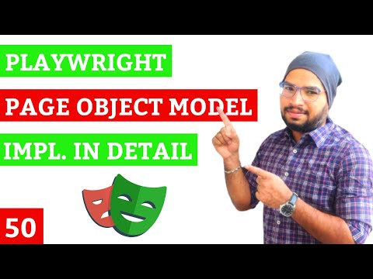
Why POM (Page Object Model)?
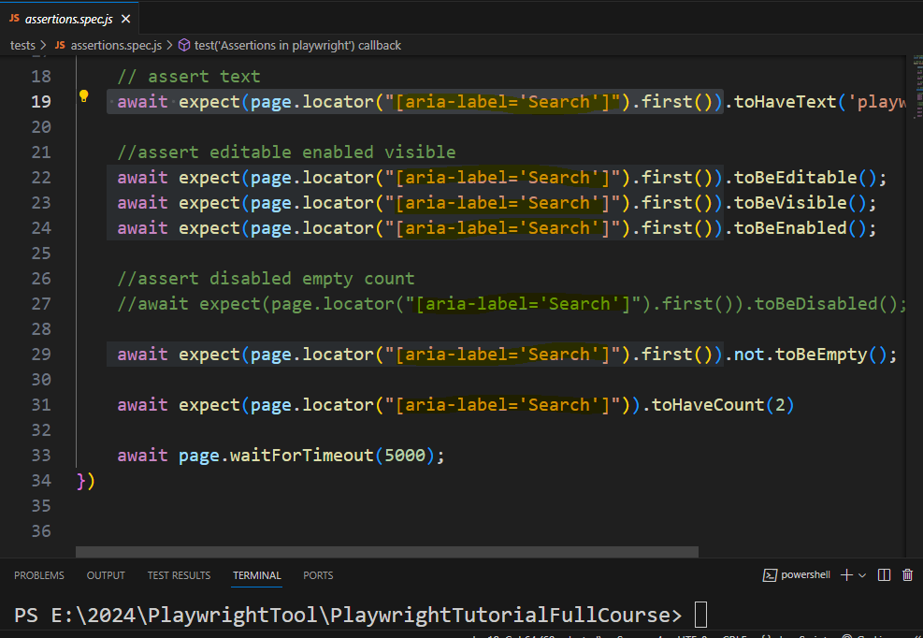

What is Page Object Model?
    - Page Object Model is a design pattern to create object repository for web page elements
    - For each web page there will be corresponding page class
    - Page class contains all the web page elements of that page & also it contains page methods which perform operations on those web elements

Advantages:
    - Code will be cleaner & Easier to understand
    - Object repository is independent of test scripts
    - Test Script will be optimized because of elements respective abstraction methods in page classes

Disadvantages:
    - Time & Effort
    - Specific to project

Sample Page Object Page:
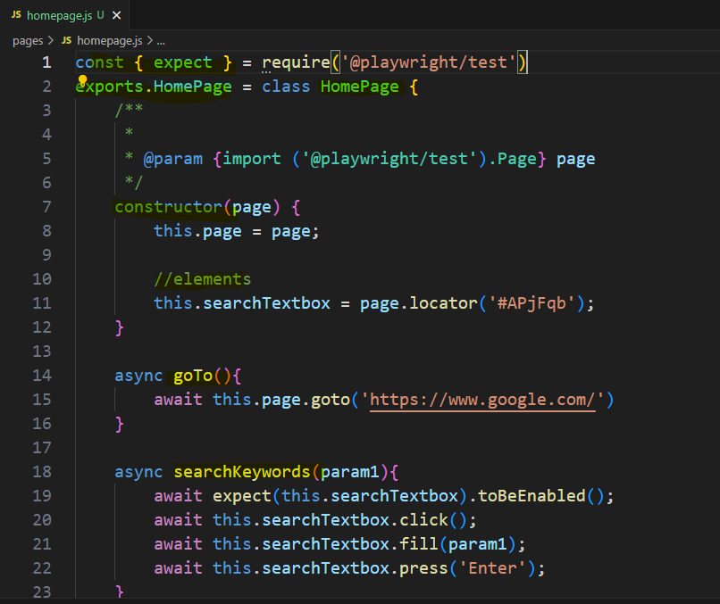

Sample Page Object Test:
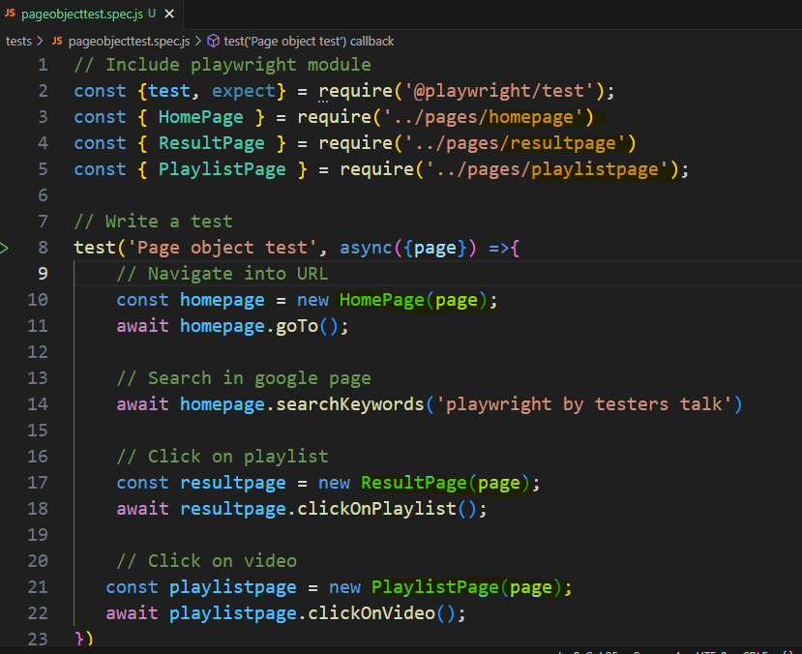

4.5 Video Recording – Test Execution
Link: https://youtu.be/cjEabtuKQG8?si=wOozJ8v4yjY6jWUq
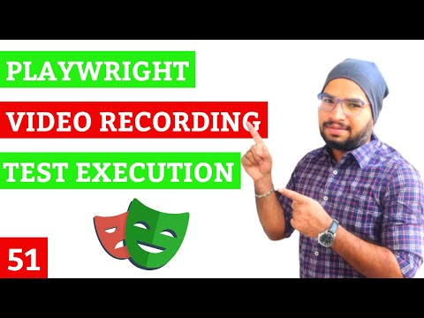
4.6 Full Screen/Maximize Browser in Playwright
Link: https://youtu.be/SQisY9urSMQ?si=9oXsZ1gstUCrMQF-
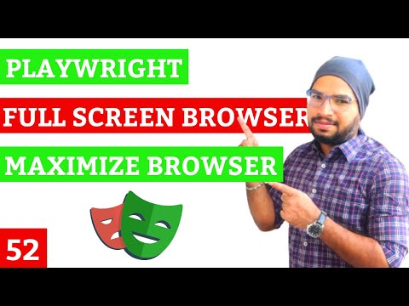

- Playwright - API Testing
  - Post API Request using static API request body
Link: https://youtu.be/-hBnQVtfrqk?si=nrtB96j5kn16Vi-q
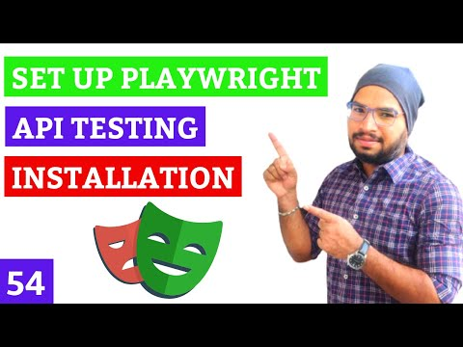
Link: https://youtu.be/yfQXwALSWxQ?si=FfuTeNMR633YACM_
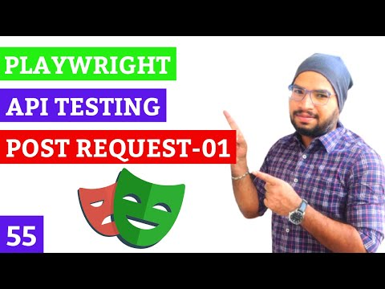
Link: https://youtu.be/b_z5o9Easg8?si=ooueTeF-QsBmPWW7
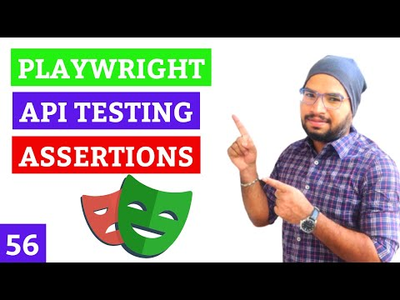

- Install Playwright
- How to get Postman Collections?
- Playwright API Testing GitHub?
- Create POST API Request
- Validate status code
- Validate JSON API Response
- Validate Nested JSON object

  - Post API Request using static JSON file
Link: https://youtu.be/GRSTmxTrPSk?si=n_ll1YzL-QVn3EOl
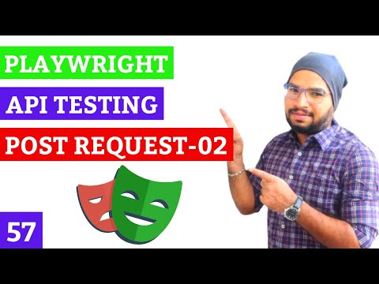

  - Post API Request using dynamic API request body
Link: https://youtu.be/XdeuRTUrdbU?si=PBOzIKJ7sk-KPGOf
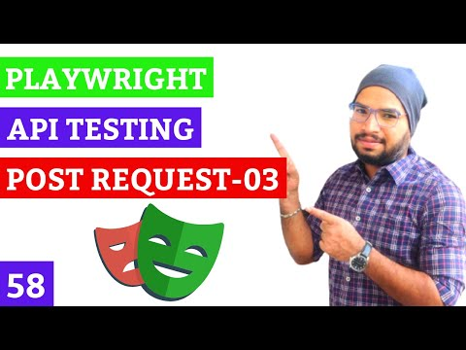

  - Post API Request using dynamic JSON file
Link: https://youtu.be/QG9Lk95a5Yw?si=DhA9bvx5GS8qX8hb
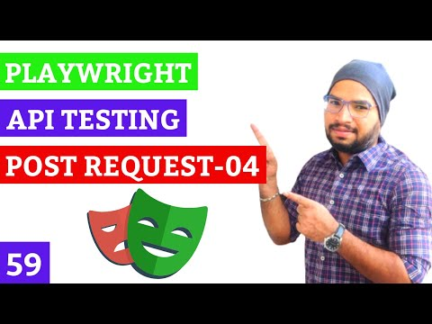

  - GET API Request
Link: https://youtu.be/R1dOOKXp5x8?si=4O-pIiswOF19BdY_
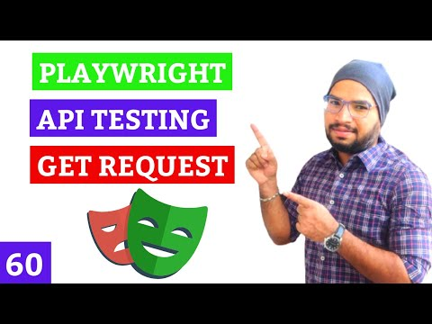

  - Query Parameters
Link: https://youtu.be/cJ6pTKk0Zc8?si=5i2p52SoAZLHPDE0
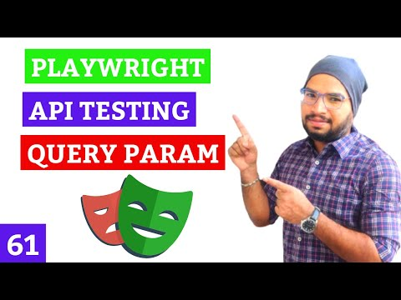

  - PUT API Request
Link: https://youtu.be/E8XYmzgqPpU?si=3JwLnjeWKyOHNihb
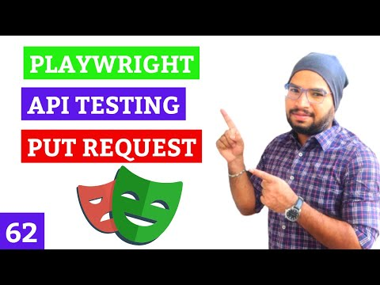

  - PATCH API Request
Link: https://youtu.be/3VFgU2i2_t0?si=DxZzlat-9n91PGaF
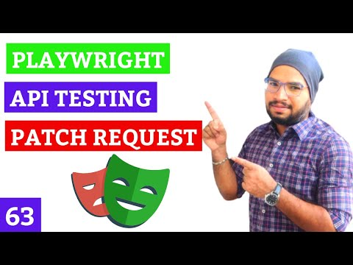

  - DELETE API Request
Link: https://youtu.be/0IsHFiELmV8?si=pqnc67rLQCueBnSZ
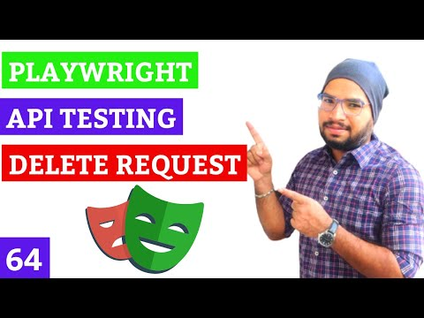

5.10 Allure Report with Playwright
Link: https://youtu.be/TY1ANl0mzPg?si=4g-Gc3PKhE1pCwIZ
- Step1: Install Allure Report command-line tool
npm install --save-dev allure-commandline
- Step2: Install the Allure Playwright adapter.
npm install --save-dev allure-playwright
- Step3: Add below config in playwright.config.js file.
reporter:[
['html'],
['allure-playwright']
],
- Step4: Run Playwright tests.
npx playwright test
- Step5: Generate Allure Report
npx allure serve allure-results

- Azure DevOps Pipeline, Contexts etc.
  - Playwright with Azure DevOps Pipeline
  - Create Repository
Link: https://youtu.be/5XdGybA392I?si=Ye2xitN0rL33canj
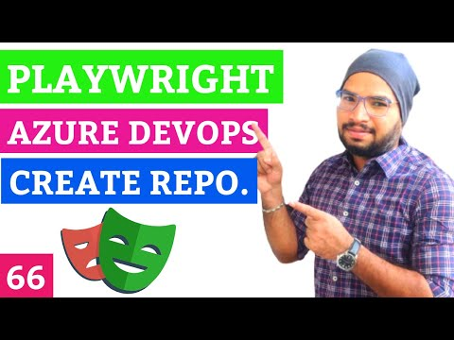

  - Install Azure Repos Extension
  - Push Playwright Test Automation Framework

  - Create Azure DevOps Pipeline
  - Run Azure DevOps Pipeline
    - Auto Run Pipeline Based PR Merge

  - Add Playwright Report into Azure Pipeline [Publish Pipeline Artifacts]
Link: https://youtu.be/zc5I4tbsaPo?si=e40ztxxLl3o2sx49
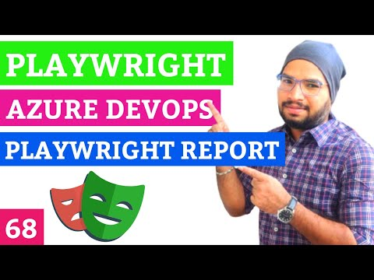

  - Publish Junit format Test Results
Link: https://youtu.be/ihmZyYDMaeA?si=ivsgdH5tq1J9ymFo
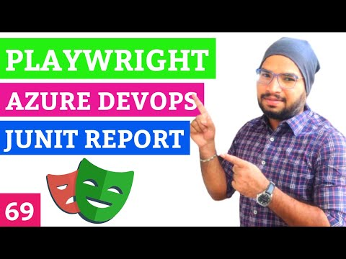

  - Create Azure DevOps Pipeline without using .yml file.
    - Playwright Report
    - Test Results

- How to run only failed tests?
https://youtu.be/Ojgt8m5UWvM?si=3Je_Z6tmNLWVqEI3
